# INDEX

|  |  |  |  |  |
| --- | --- | --- | --- | --- |
| **Sr. No.** | **Title** | **Pg No.** | **Date** | **Sign** |
| 1 | 1. Use the following tools to perform footprinting and reconnaissance 2. Recon-ng (Using Kali Linux) 3. FOCA Tool 4. Windows Command Line Utilities  * Ping * Tracert using Ping * Tracert * NSLookup  1. Website Copier Tool – HTTrack 2. Metasploit (for information gathering) 3. Whois Lookup Tools for Mobile – DNS Tools, Whois, Ultra Tools Mobile 4. Smart Whois 5. eMailTracker Pro 6. Tools for Mobile – Network Scanner, Fing – Network Tool, Network Discovery Tool, Port Droid Tool 7. Scan the network using the following tools:    1. Hping2 / Hping3    2. Advanced IP Scanner    3. Angry IP Scanner    4. Masscan    5. NEET    6. CurrPorts    7. Colasoft Packet Builder | 5  30 | 7/9/2022  15/11/2022 |  |
| 2 | 1. Perform Network Discovery using the following tools:    1. Solar Wind Network Topology Mapper    2. Network View    3. LANState Pro 2. Use the following censorship circumvention tools: 3. Tails OS   c. Use Scanning Tools for Mobile – Network Scanner, Fing – Network Tool, Network Discovery Tool, Port Droid Tool | 39  40  41 | 10/10/2022  17/10/2022  18/10/2022 |  |

|  |  |  |  |  |
| --- | --- | --- | --- | --- |
| 3 | 1. Perform Enumeration using the following tools:    1. Nmap    2. NetBIOS Enumeration Tool    3. SuperScan Software    4. Hyena    5. SoftPerfect Network Scanner Tool    6. SolarWinds Engineer’s Toolset    7. Wireshark 2. Perform the vulnerability analysis using the following tools:    1. Nessus | 42  45 | 28/9/2022  15/12/2022 |  |
| 4 | 1. Perform the System Hacking using the following tools: 2. Winrtgen 3. PWDump 4. Ophcrack 5. NTFS Stream Manipulation 6. ADS Spy 7. Snow 8. Quickstego 9. Clearing Audit Policies 10. Clearing Logs | 45 | 14/11/2022 |  |
| 5 | 1. Use wireshark to sniff the network. 2. Use SMAC for MAC Spoofing. | 63  64 | 05/11/2022 |  |
| 6 | 1. Use Social Engineering Toolkit on Kali Linux to perform Social Engineering using Kali Linux. 2. Perform the DDOS attack using the following tools: 3. HOIC 4. LOIC 5. Metasploit | 66  70 | 11/11/2022  11/11/2022 |  |
| 7 | 1. Use the following tools to protect attacks on the web servers:    1. ID Server | 74 | 29/11/2022 |  |
|  | * 1. Use the following tools for cryptography  1. HashCalc 2. Advanced Encryption Package 3. CrypTool | 76 | 12/12/2022 |  |

**Practical No. 1**

## A. Tools to perform footprinting and reconnaissance

1. **Recon-ng (Using Kali Linux)**

# marketplace install hackertarget

# modules load hackertarget

# options set SOURCE Tesla.com

# info

# input

# run

1. Run the Application Recon-ng or open the terminal of Kali-Linux and type recon-ng and hit enter.

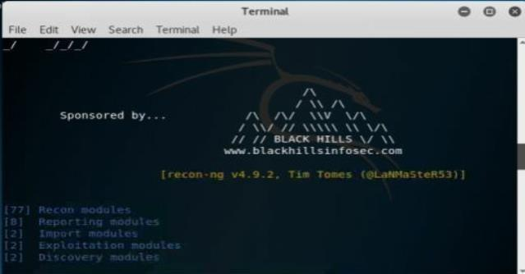

1. Enter the command “***show modules***” to show all independent modules available.

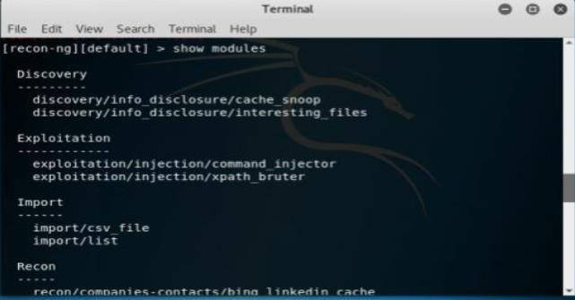

1. You can search for any entity within a module. For example, in above figure, the command “***Search Netcraft***” is used.

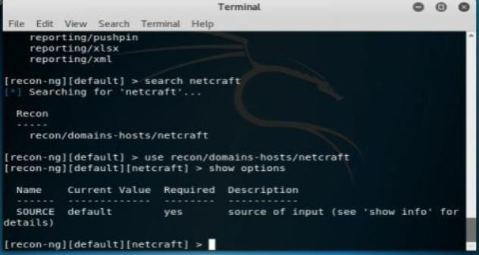

1. To use the Netcraft module, use the command syntax “***use recon/domain-hosts/Netcraft***” and hit enter.

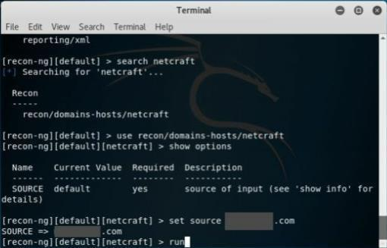

1. Set the source by the command “***set source*** *[domain]*.” Press enter to continue. Type ***Run*** to execute and press enter.

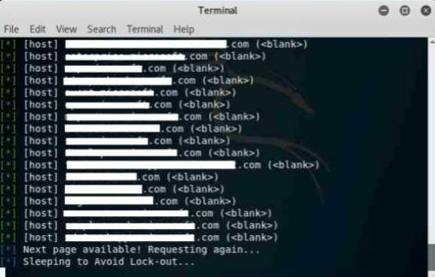

## FOCA Tool

1. Download the software ***FOCA*** from https://www.elevenpaths.com. Now,Go to ***Project > New Project.***

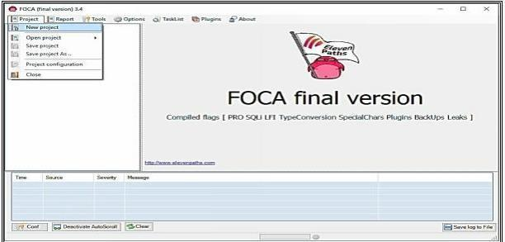

1. Now, Enter the Project Name, Domain Website, Alternate Website (if required), Directory to save the results, Project Date. Click Create to proceed.

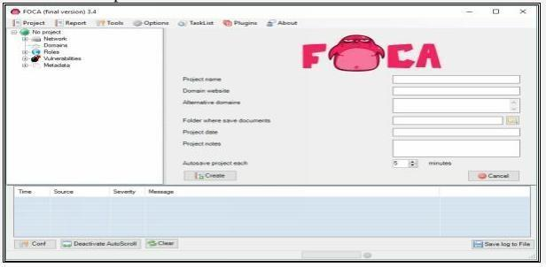

1. Select the Search Engines, Extensions, and other parameters as required. Click on Search All Button.

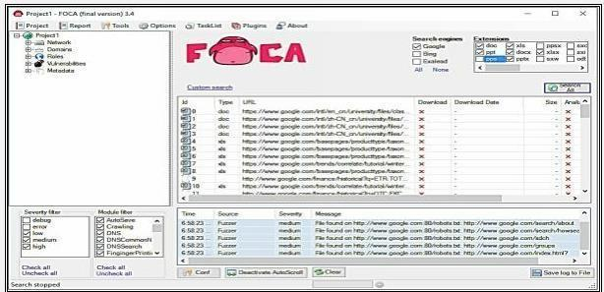

**4** -Once Search completes, the search box shows multiple files. You can select the file, download it, Extract Metadata, and gather other information like username, File creation date, and Modification.

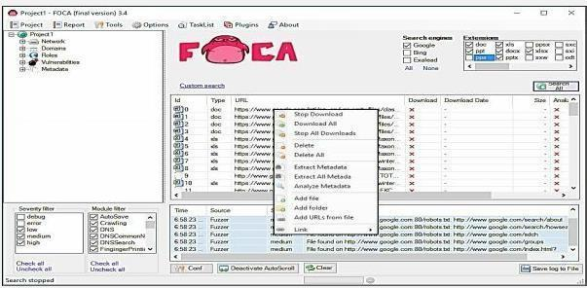

* 1. **Windows Command Line Utilities**

**Topology Diagram:**

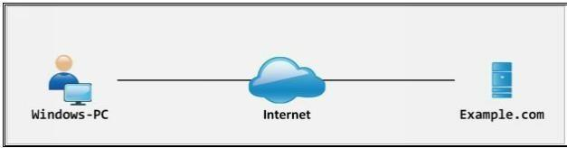

## • Ping

**1**- Open Windows Command Line (cmd) from Windows PC

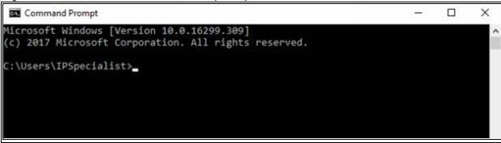

**2** -Enter the command “ **Ping example.com** ” to ping.

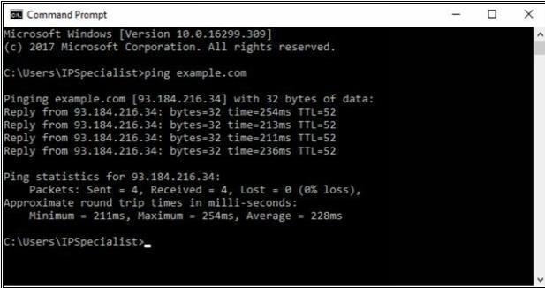

From the output, you can observe and extract the following information:

* Example.com is live
* IP address of example.com.
* Round Trip Time
* TTL value
* Packet loss statistics

1. Now, Enter the command “ Ping example.com –f –l 1500 ” to check the value of fragmentation. 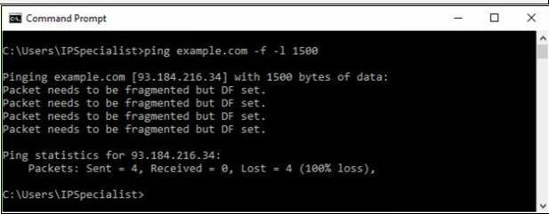

The output shows “ **Packet needs to be fragmented but DF set** ” which means 150o bits will require being fragmented. Let’s try again with smaller value:

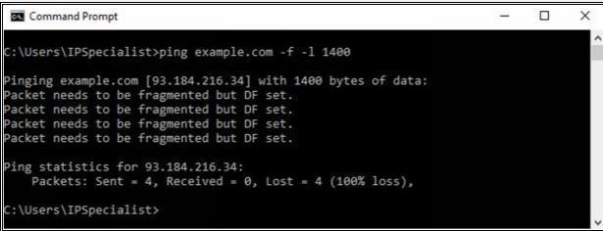

Output again shows “ **Packet needs to be fragmented but DF set** ” which means 140o bits will require being fragmented. Let’s try again with smaller value:

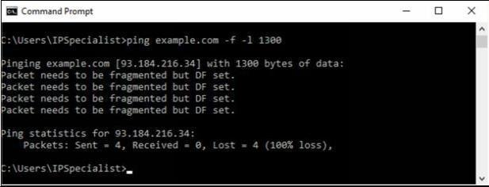

Output again shows “ **Packet needs to be fragmented but DF set** ” which means 130o bits will require being fragmented. Let’s try again with smaller value:

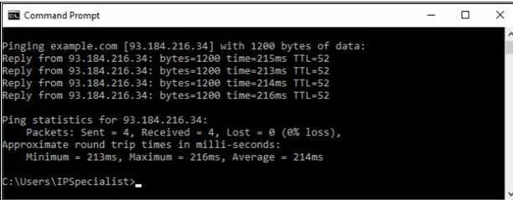

The output shows the reply now, which means 120o bits will not require being fragmented. You can try again to get the more appropriate fragment value.

**• Tracert using Ping**

Enter the command **“Tracert example.com”** to trace he target.

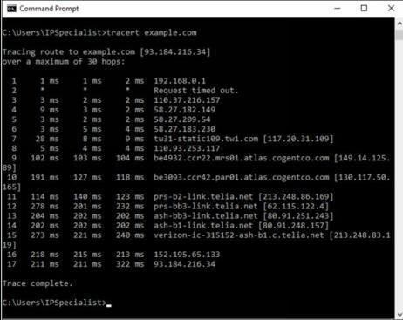

From the output, you can get the information about hops between the source (your PC) and the destination (example.com), response times and other information.

## • Tracert

Consider an example, in which an attacker is trying to get network information by using tracert.

After observing the following result, you can identify the network map.

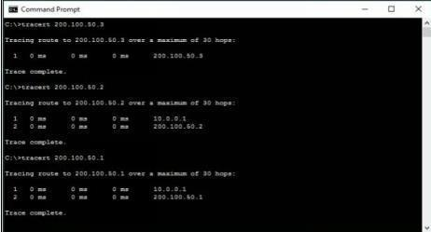

10.0.0.1 is the first hop, which means it is the gateway. Tracert result of 200.100.50.3 shows, 200.100.50.3 is another interface of first hop device whereas connected IP includes 200.100.50.2 & 200.100.50.1.

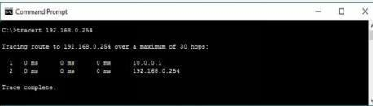

192.168.0.254 is next to last hop 10.0.0.1. It can either connected to 200.100.50.1 or 200.100.50.2. To verify, trace next route.

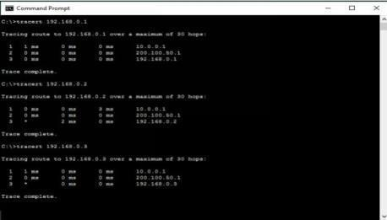

192.168.0.254 is another interface of the network device, i.e. 200.100.50.1 connected next to 10.0.0.1. 192.168.0.1, 192.168.0.2 & 192.168.0.3 are connected directly to 192.168.0.254.

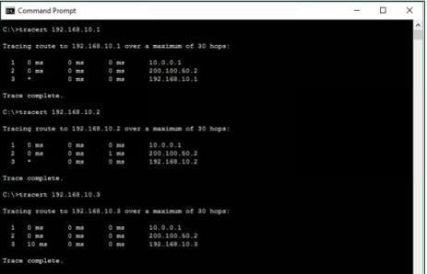

192.168.10.254 is another interface of the network device i.e. 200.100.50.2 connected next to 10.0.0.1. 192.168.10.1, 192.168.10.2 & 192.168.10.3 are connected directly to 192.168.10.254.

### Traceroute Tools

Traceroute tools are listed below: -

|  |  |
| --- | --- |
| **Traceroute Tools** | **Website** |
| Path Analyzer Pro | www.pathanalyzer.com |
| Visual Route | www.visualroute.com |
| Troute | www.mcafee.com |
| 3D Traceroute | www.d3tr.de |

The following figure shows graphical view and other trace information usingVisual Route tool.

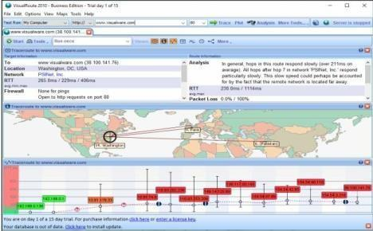

## • DNS Zone Transfer Enumeration Using NSLookup

1. Go to Windows command line (CMD) and enter Nslookup and press Enter.

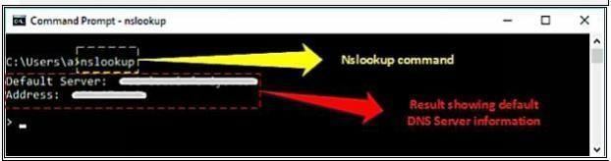

1. Command prompt will proceed to " > " symbol.
2. Enter " server <DNS Server Name> " or " server <DNS Server Address> ".
3. Enter set type=any and press Enter. It will retrieve all records from a DNS server.
4. Enter ls -d <Domain> this will display the information from the target domain (if allowed).

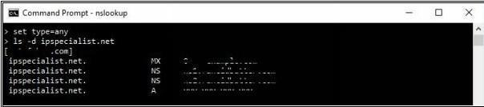

1. If not allowed, it will show the request failed.

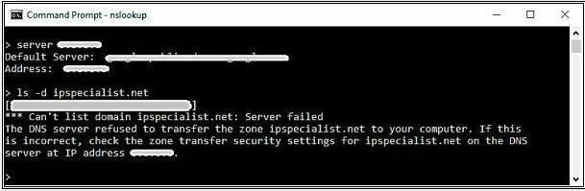

1. Linux support dig command, At a command prompt enter dig <domain.com> axfr.

## iv. Website Copier tool (HTTrack)

1. Download and Install the WinHTTrack Website Copier Tool from the website [**http://www.httrack.com.**](http://www.httrack.com/)You can check the compatibility of HTTrack Website copier tool on different platforms such as Windows, Linux, and Android from the website.

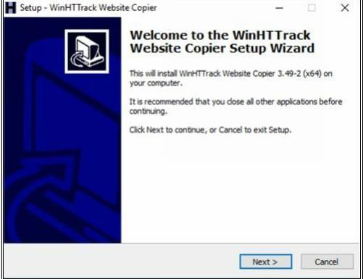

1. HTTrack Website Copier tool installation.

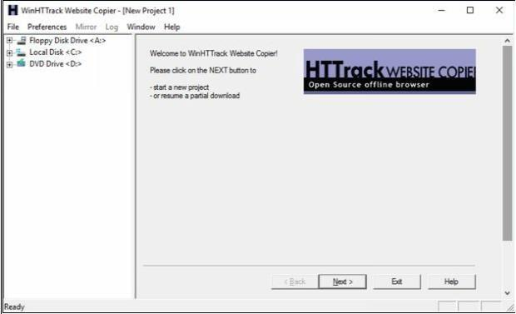

1. Click Next

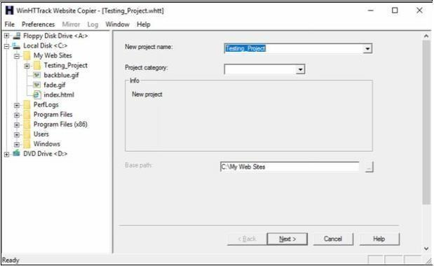

1. Enter a Project name, as in our case, **Testing_Project.**

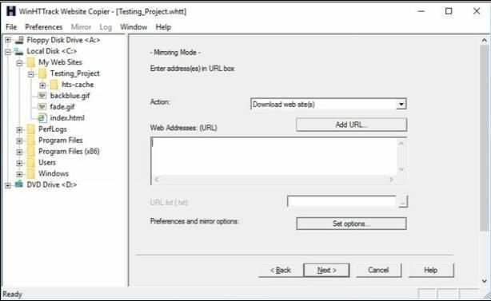

1. Click on **Set Options** button.

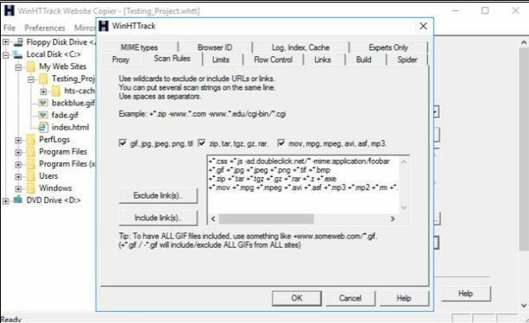

1. Go to **Scan Rules** Tab and Select options as required.

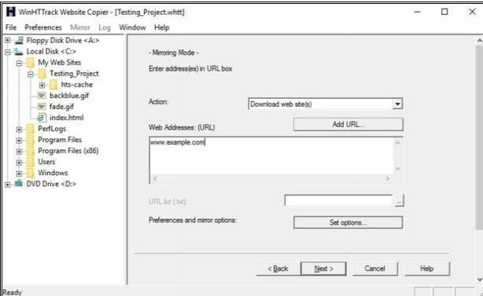

1. Enter the Web Address in the field and Click Next.

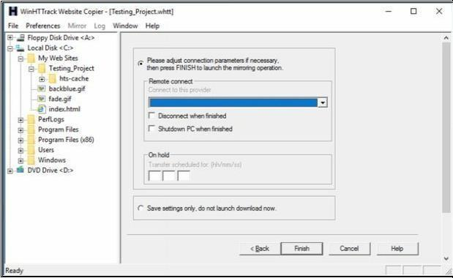

1. Click Next.

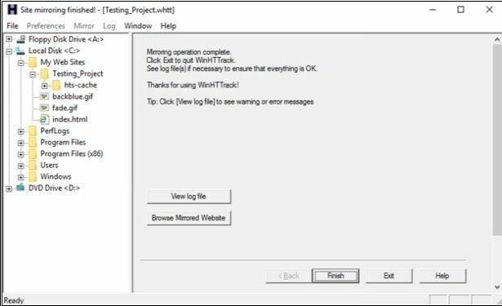

1. Click **Browse Mirrored Website**.

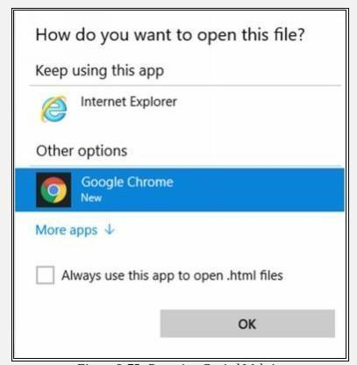

1. Select your favorite web browser.

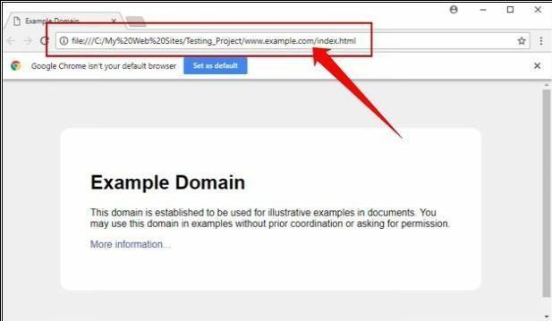

Observed the above output. Example.com website is copied into a local directory and browsed from there. Now you can explore the website in an offline environment for the structure of the website and other parameters.

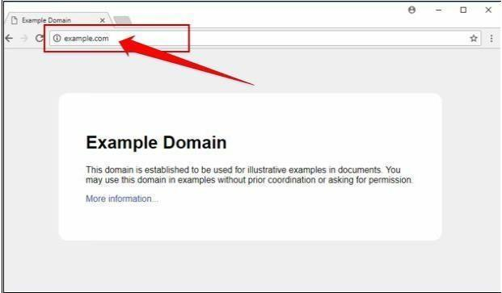

To make sure, compare the website to the original example.com website. Open a new tab and go to URL example.com.

## v. Metasploit (for information gathering)

**Topology Information:** In this lab, we are running Metasploit Framework on a private network

10.10.50.0/24 where different hosts are live including Windows 7, Kali Linux, Windows Server 2016 and others.

1. Open Kali Linux and Run Metasploit Framework.

**# Search portscan**

**# Use 5 (auxiliary/scanner/portscan/tcp)**

**# Options**

**# Set ports 22,80,443**

**# Set RHOST 35.186.238.101**

**# Run**

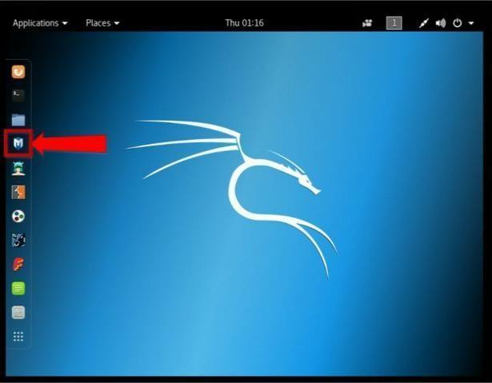

1. Metasploit Framework initialization as shown below in the figure.

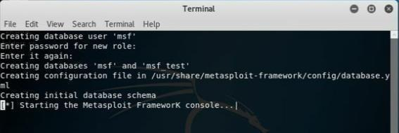

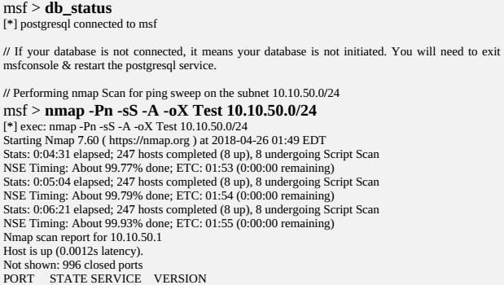

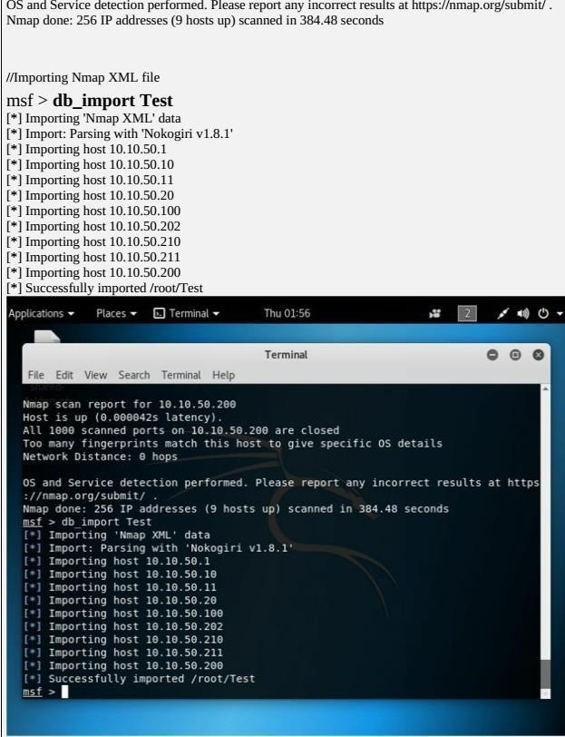

msf > hosts

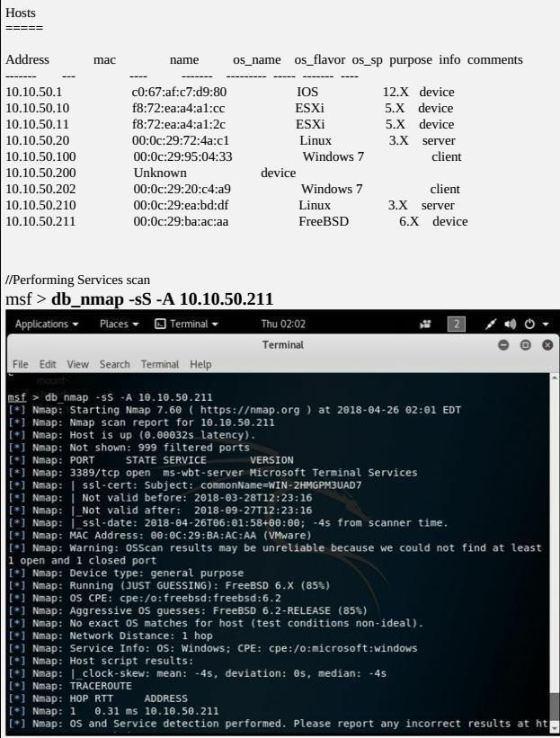

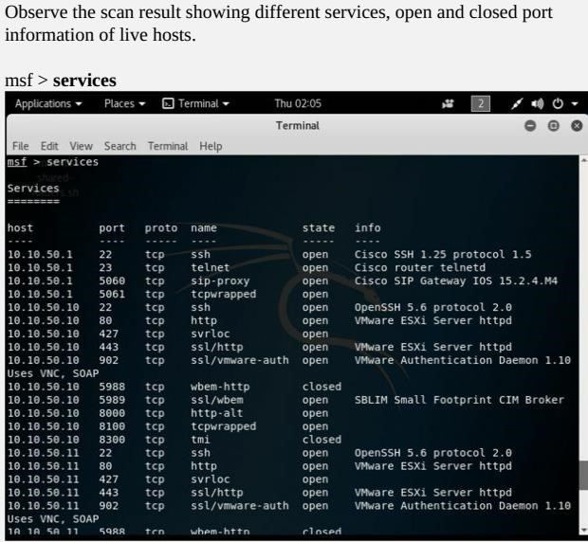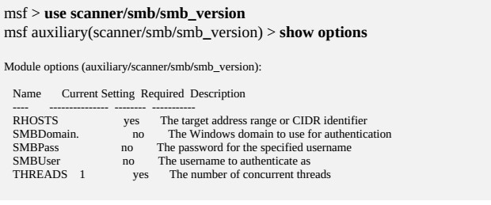

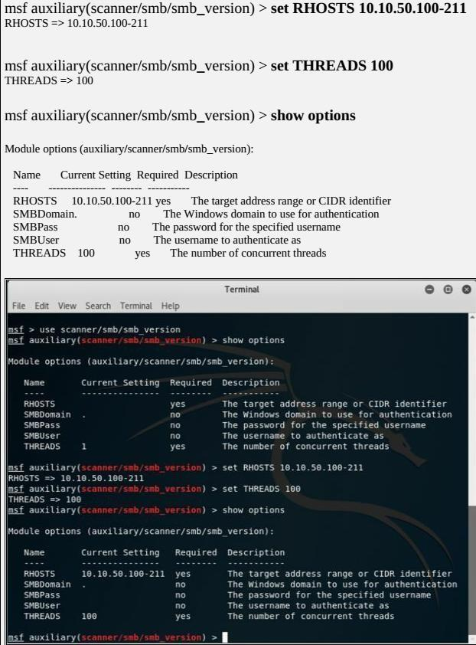

Observe the OS_Flavor field. SMB scanning scans for Operating System Flavor for the RHOST range configured.

## vi. Whois Lookup Tools for Mobile – DNS Tools, Whois, Ultra Tools Mobile

1. Go to the URL [**https://www.whois.com/**](https://www.whois.com/)

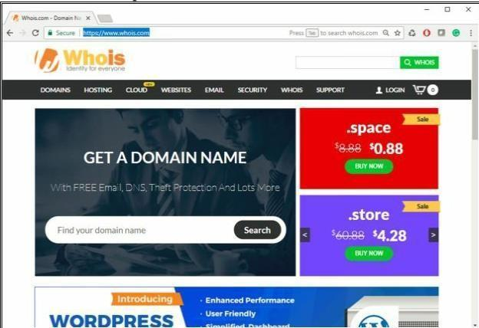

1. A search of Target Domain

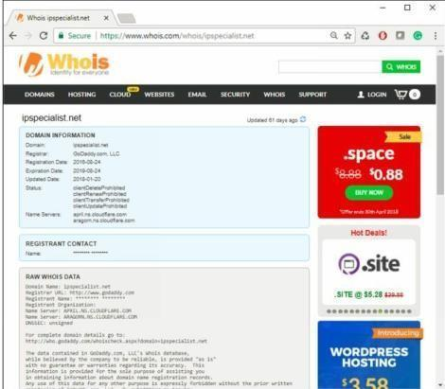

You can go to ***https://whois.domaintools.com*** can enter the targeted URL for whois lookup information

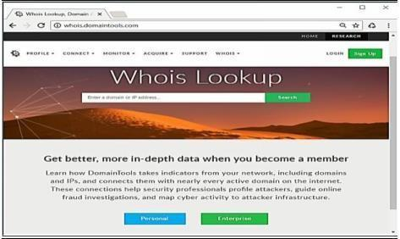

## vii. Smart Whois

You can download software “***SmartWhois***” from ***www.tamos.com*** for Whois lookup as shown in the figure below: -

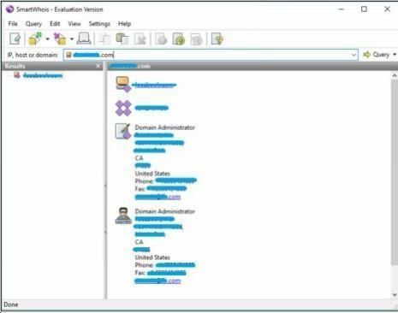

## viii. eMailTracker Pro

Click on Trace Headers/Trace email address and enter the Message Header and click Okay. The Status of the Trace will be shown inside Trace Reports

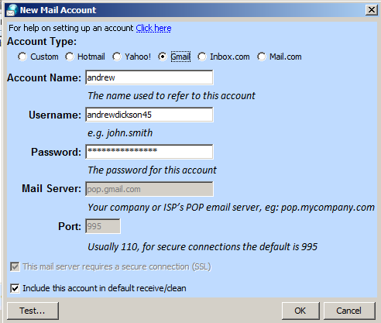

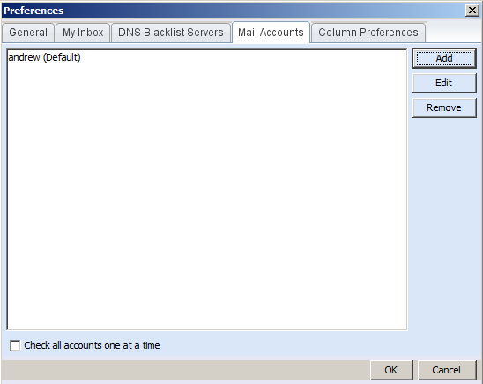

## ix. Tools for Mobile – Network Scanner, Fing – Network Tool, Network Discovery Tool, Port Droid Tool

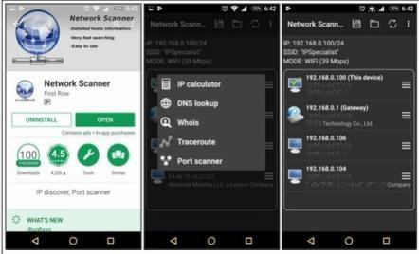

*Scanning Tool for Mobile*

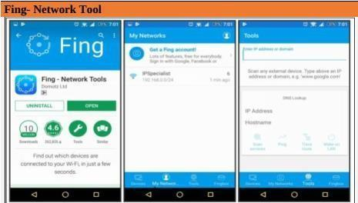

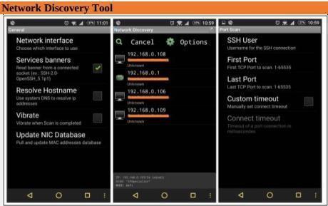

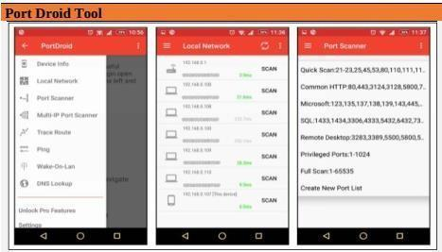

1. **Scan the network using the following tools:**

## i. Hping2 / Hping3

## 

Using Hping commands on Kali Linux, we are pinging a Window 7 host with different customized packets in this lab.

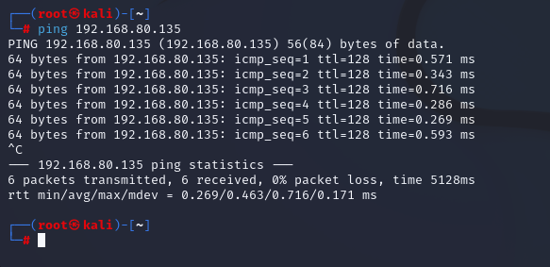

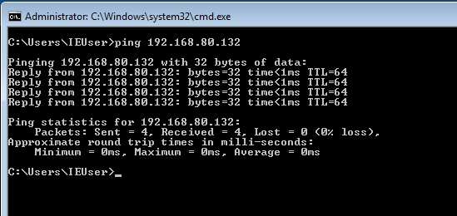

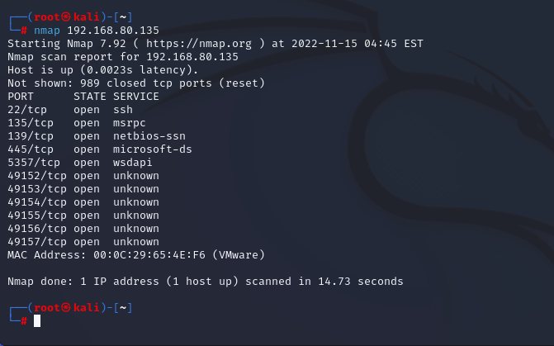

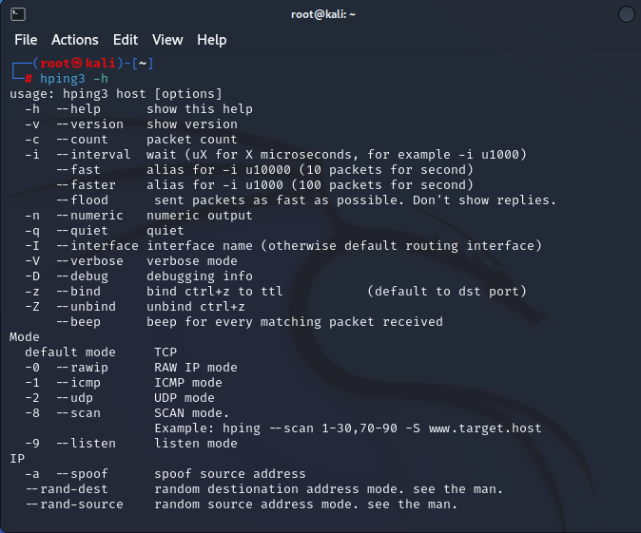

Command:  man hping3

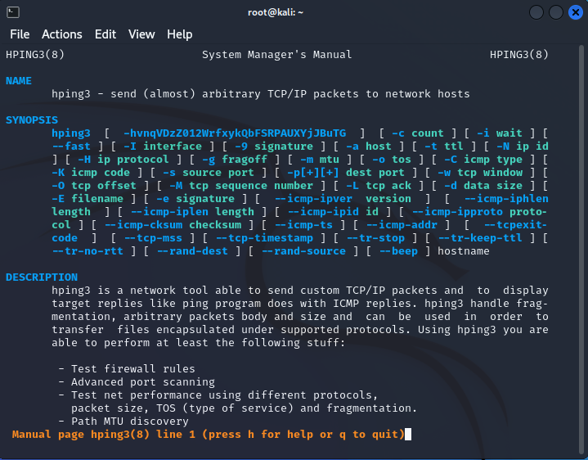

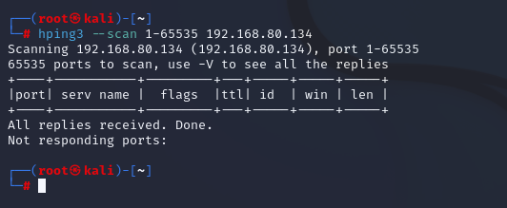

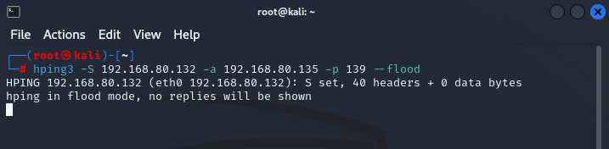

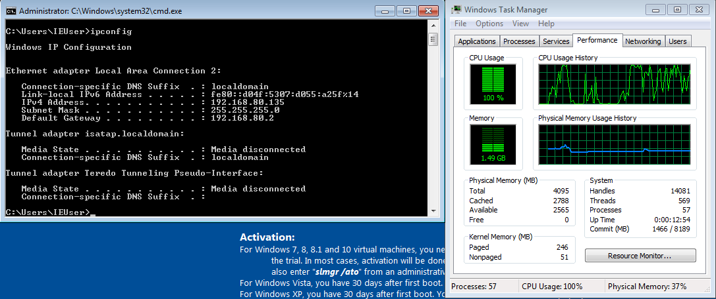

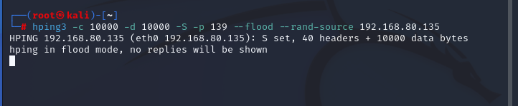

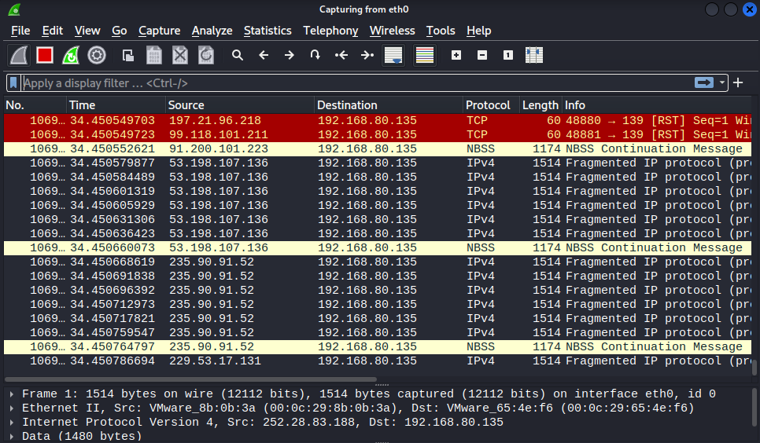

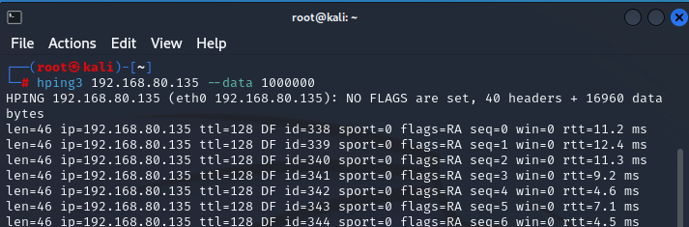

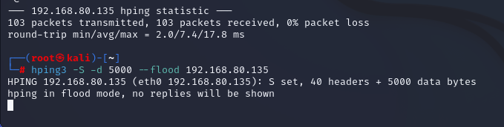

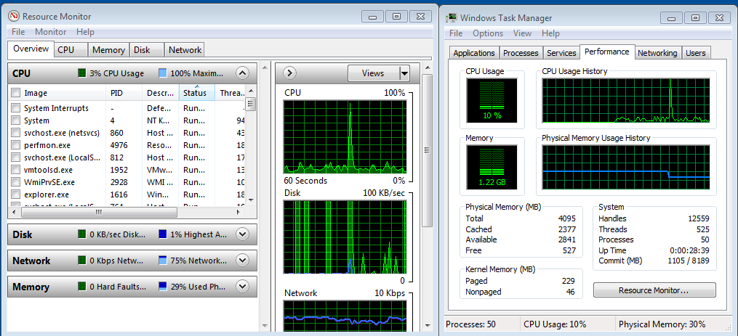

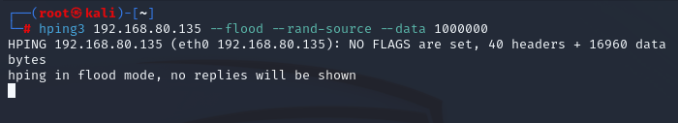

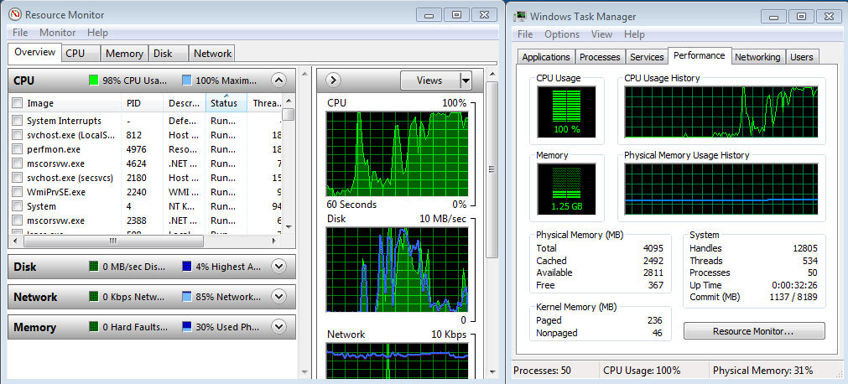

## ii. Advanced IP Scanner

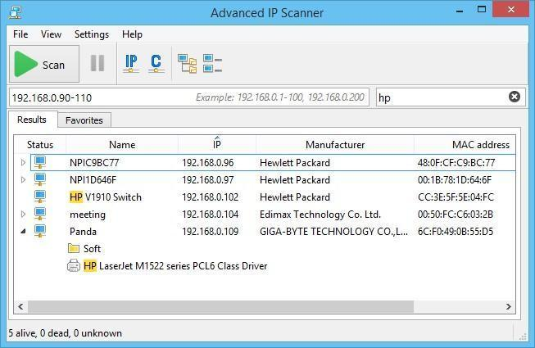

**iii. Angry IP Scanner**

It runs on Linux, Windows, and Mac OS X, possibly supporting other platforms as well.

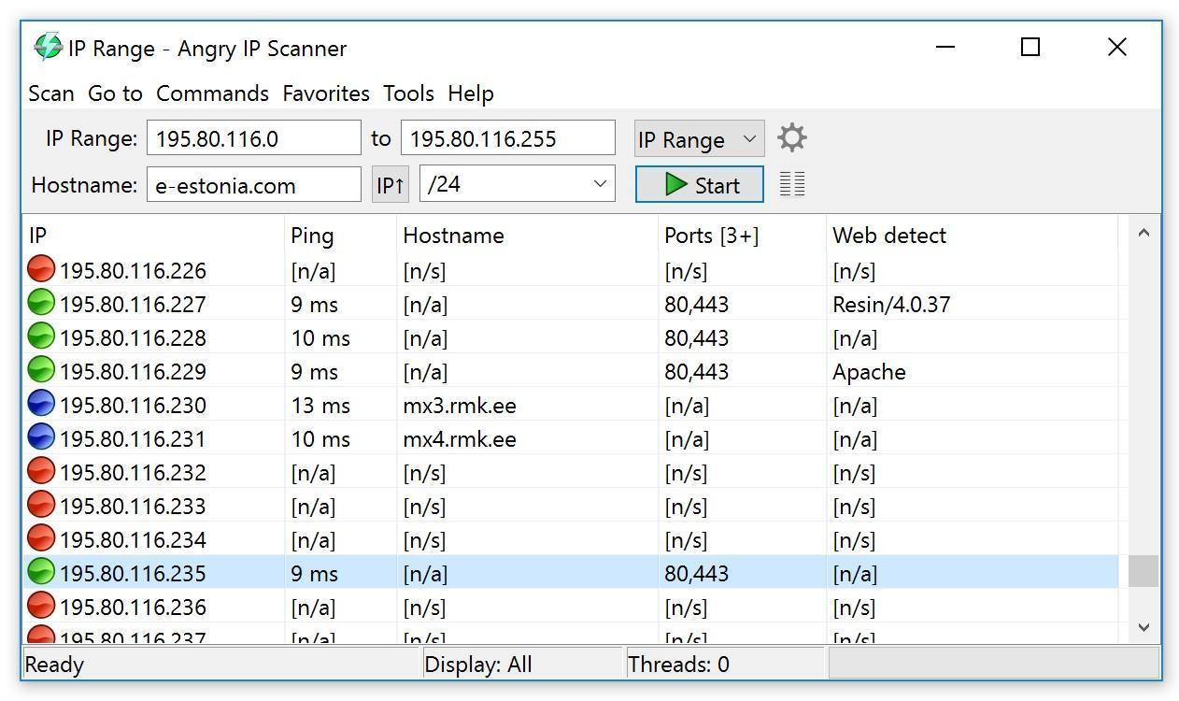

**iv. Masscan**

Scan for a selection of ports (-p22,80,445) across a given subnet (192.168.1.0/24):

root@kali:~# masscan -p22,80,445 192.168.1.0/24

Starting masscan 1.0.3 (http://bit.ly/14GZzcT) at 2014-05-13 21:35:12 GMT

-- forced options: -sS -Pn -n --randomize-hosts -v --send-eth

Initiating SYN Stealth Scan

Scanning 256 hosts [3 ports/host]

Discovered open port 22/tcp on 192.168.1.217

Discovered open port 445/tcp on 192.168.1.220 Discovered open port 80/tcp on 192.168.1.230

## v. NEET

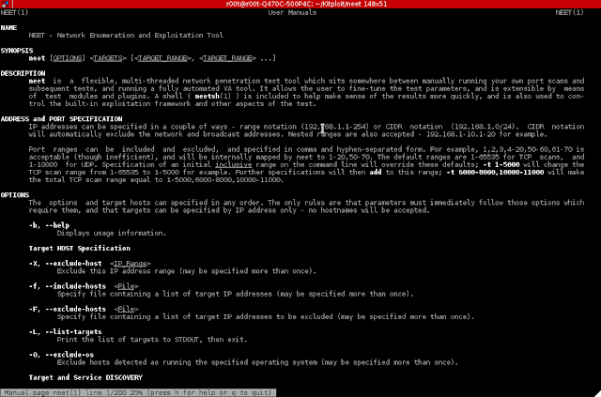

## vi. CurrPorts

**Case Study:** Using the Previous lab, we are going to re-execute HTTP Remote Access Trojan (RAT) on Windows 12 machine (10.10.50.211) and observed the TCP/IP connections to detect and kill the connection.

**Topology:**

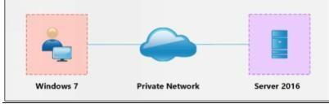

**Configuration:**

**1**. Run the application **Currports** on Windows Server 2016 and observe the processes.

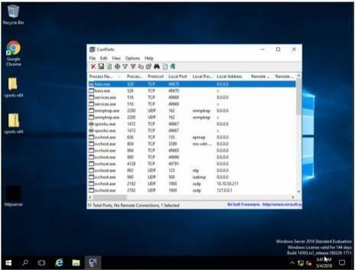

1. Run the HTTP Trojan created in the previous lab

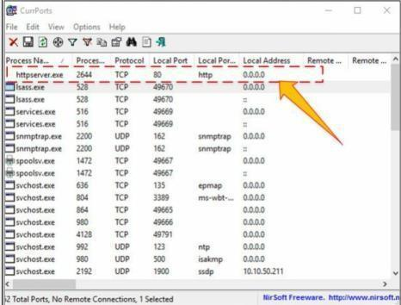

The new process is added to the list.

You can observe the process name, Protocol, Local and remote port and IP address information.

1. For more detail, right click on httpserver.exe and go to properties

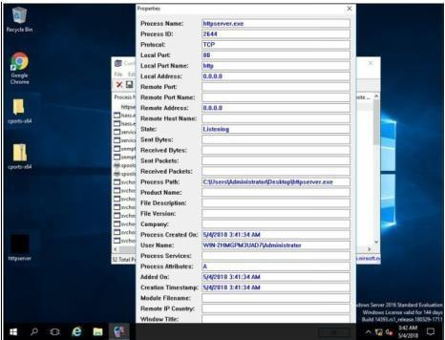

Properties are showing more details about tcp connection.

1. Go to Windows 7 machine and initiate the connection as mentioned in the previous lab using a web browser.

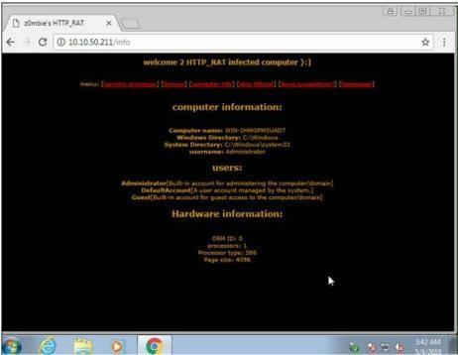

Connection successfully established.

1. Back to Windows Server 2016, Kill the connection.

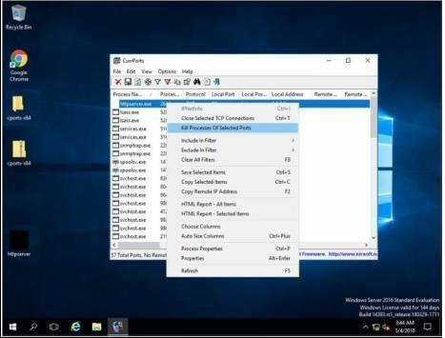

1. To verify, retry to establish the connection from windows 7.

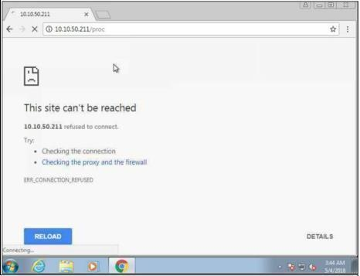

## vii. Colasoft Packet Builder

Upload .pcap file (wireshark)

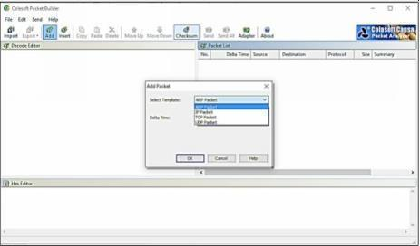

Colasoft packet builder offers Import and Export options for a set of packets. You can also **add a new packet** by clicking the. Select the Packet type from the drop-down option. Available options are: - • ARP Packet

* IP Packet
* TCP Packet
* UDP Packet

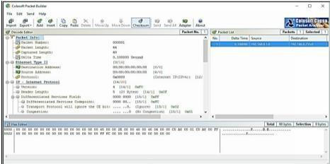

After Selecting the Packet Type, now you can customize the packet, Select the Network Adapter and Send it towards the destination.

# Practical No. 2

1. **Perform Network Discovery using the following tools:**

## Solar Wind Network Topology Mapper

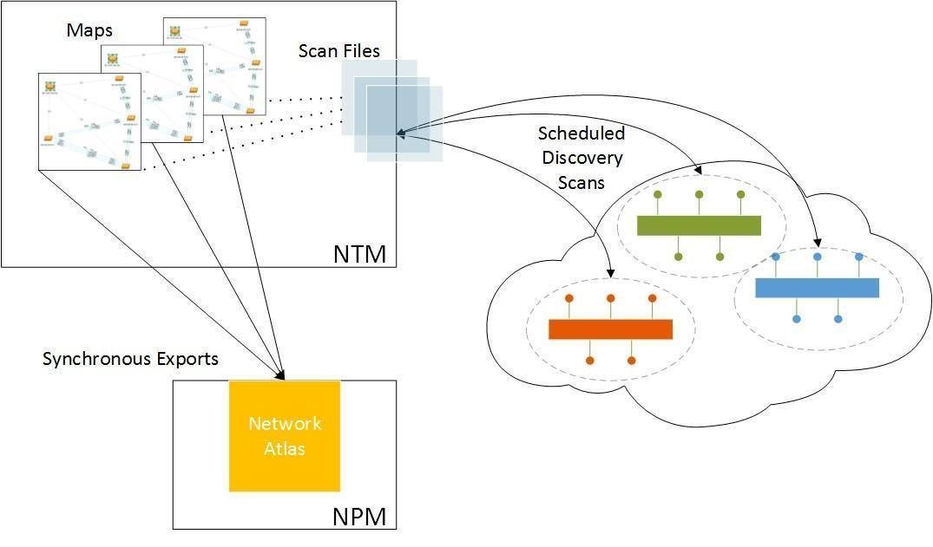

## ii. Network View

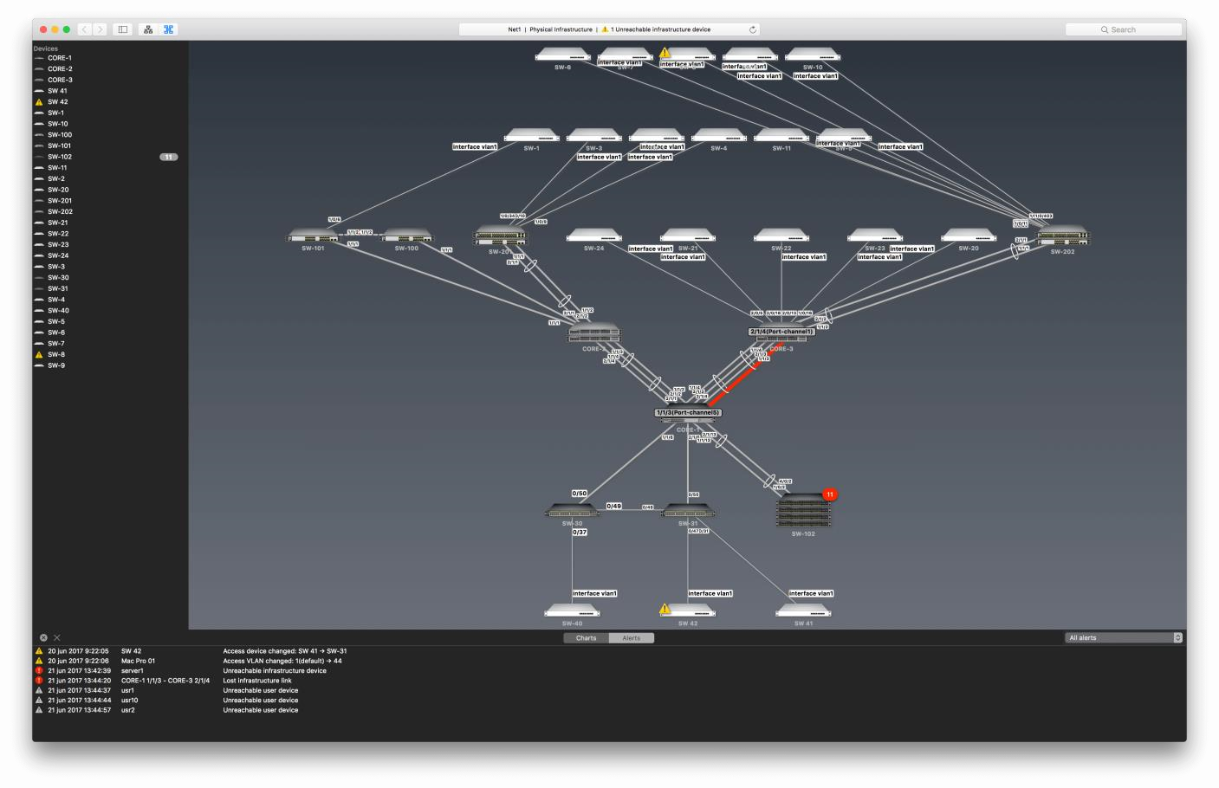

**iii. LANState Pro**

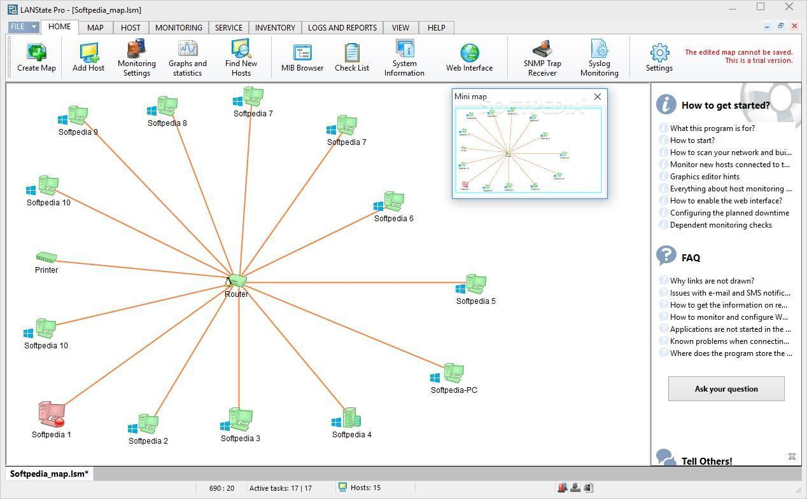

**b. Use the following censorship circumvention tools:**

**i. Tails OS**

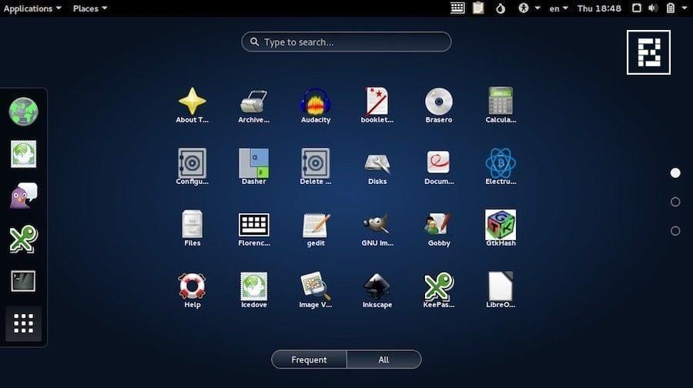

## Use Scanning Tools for Mobile – Network Scanner, Fing – Network Tool, Network Discovery Tool, Port Droid Tool

There are several basic and advanced network tools available for the Mobile device on application stores. The following are some effective tools for network Scanning.

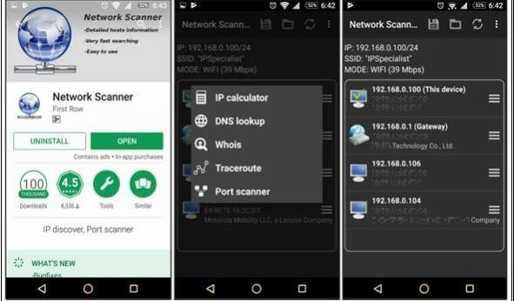

# Practical No. 3

**a. Perform Enumeration using the following tools:**

## i. Nmap

To perform OS detection with nmap perform the following: nmap -O<ip address>

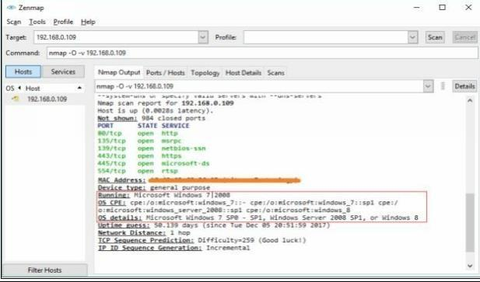

## ii. NetBIOS Enumeration Tool

**# nbtscan (remote IP) -v**

**# nmap -p (130-140) -v (remote IP) - -script=nb\***

**# nbtscan (remote IP) -v -h**

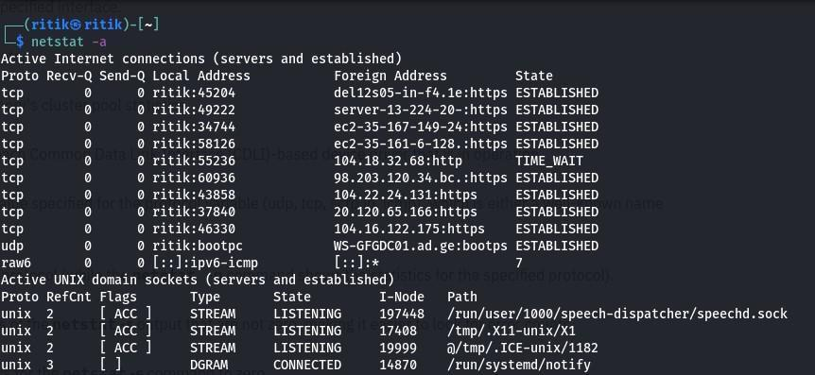

## iii. SuperScan

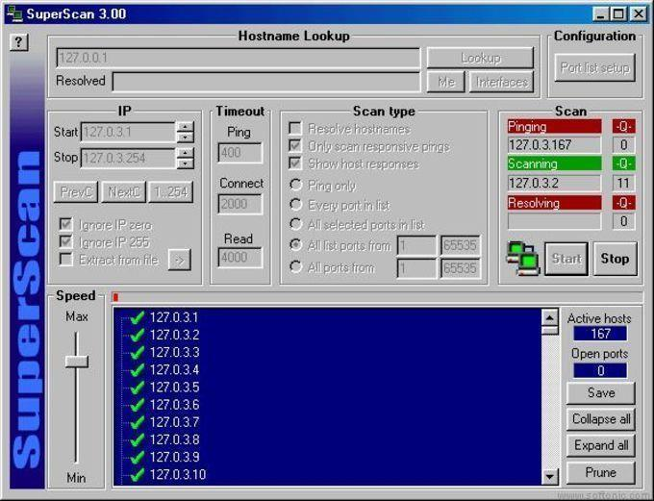

## iv. Hyena

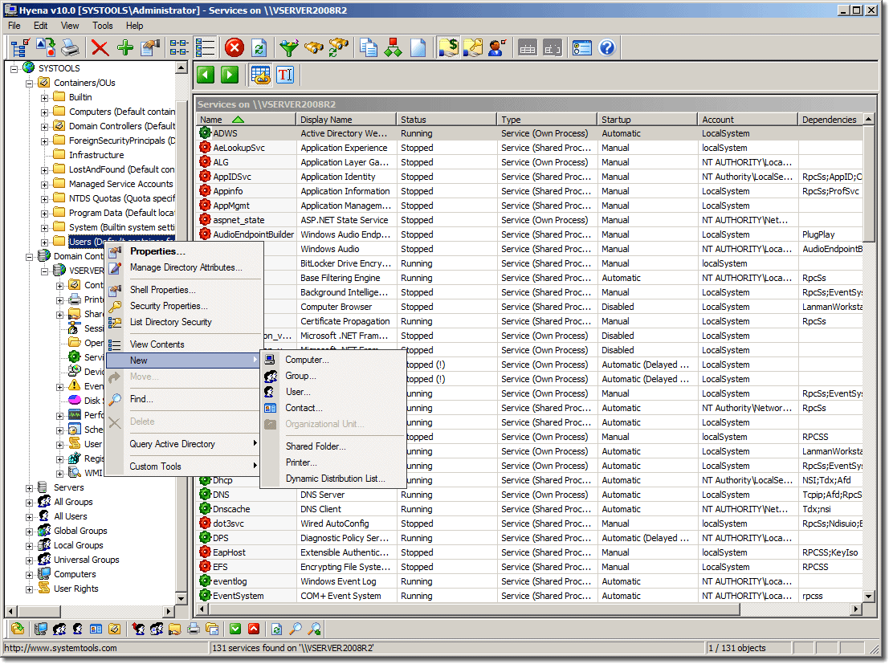

## v. SoftPerfect Network Scanner Tool

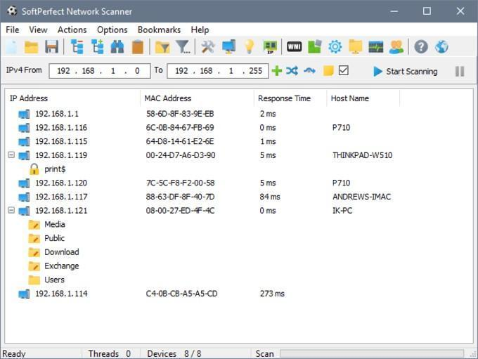

## vi. SolarWinds Engineer’s Toolset

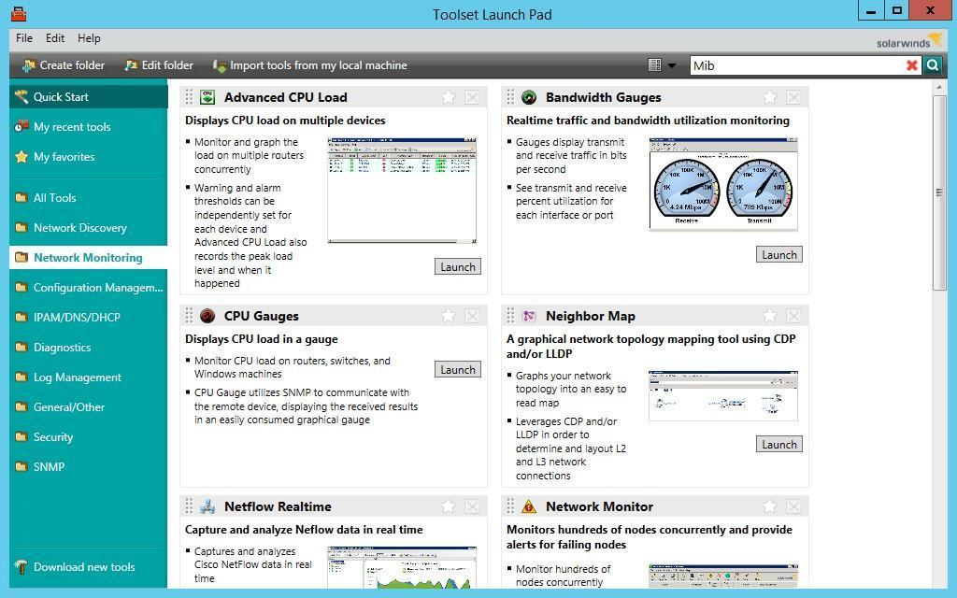

## vii. Wireshark

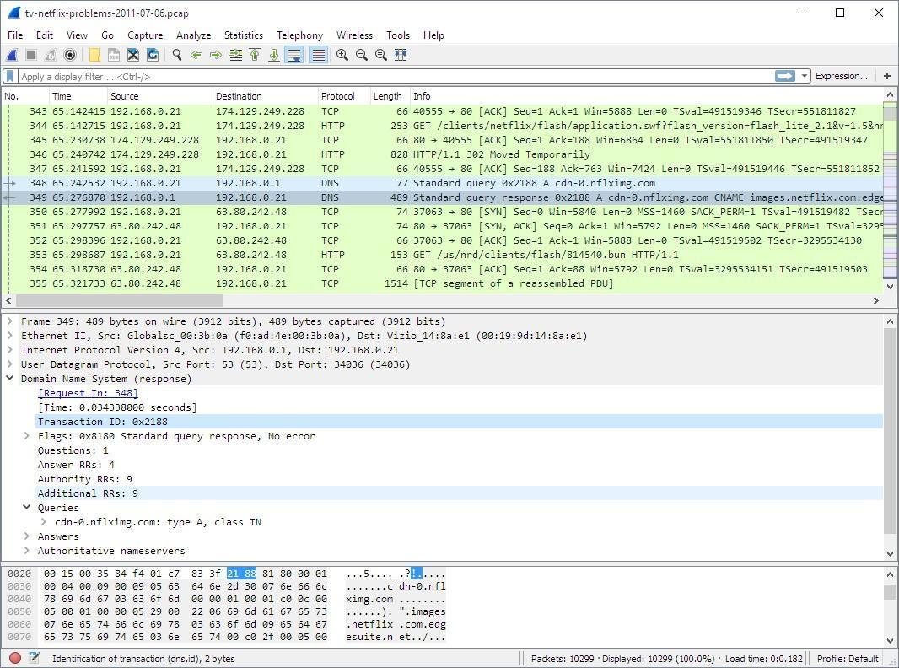

**b. Perform the vulnerability analysis using the following tools:**

## i. Nessus

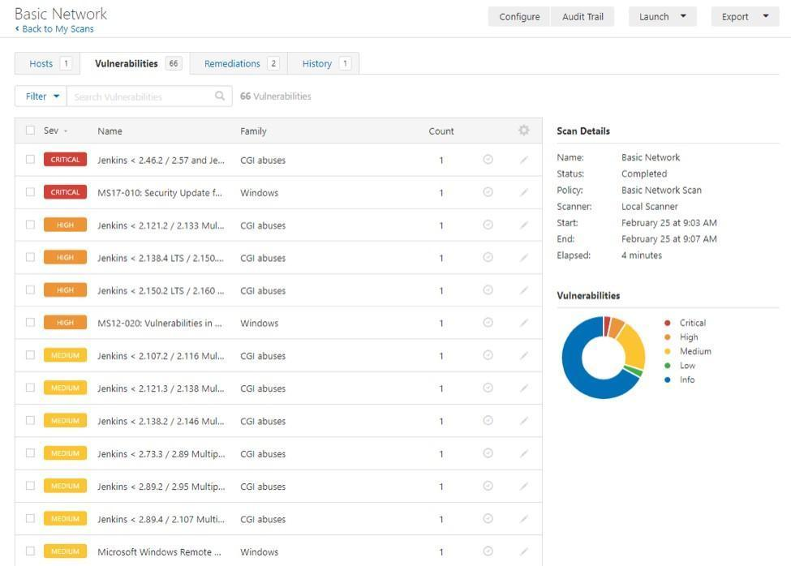

# Practical No. 4

**a. Perform the System Hacking using the following tools:**

## i. Winrtgen

In this article, we will go through the process of generating rainbow tables using WinRTGen.

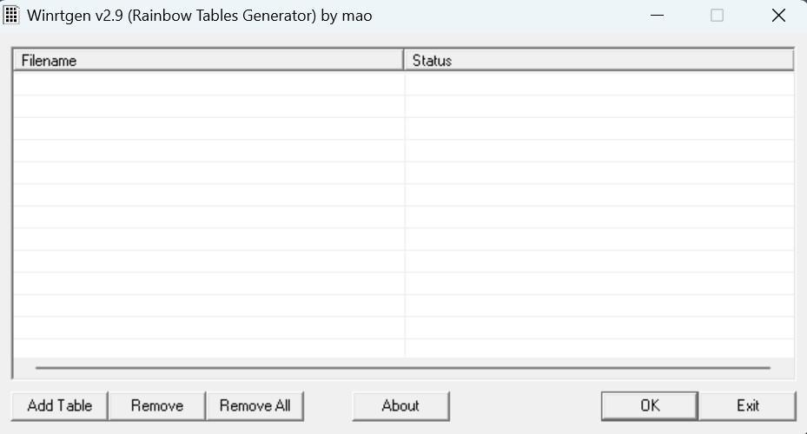

To generate rainbow tables first we will have to modify the properties of WinRTGen according to our need, and to do so Click on “**Add Table**“. After this, a new box will appear named “**Rainbow Table Properties**”

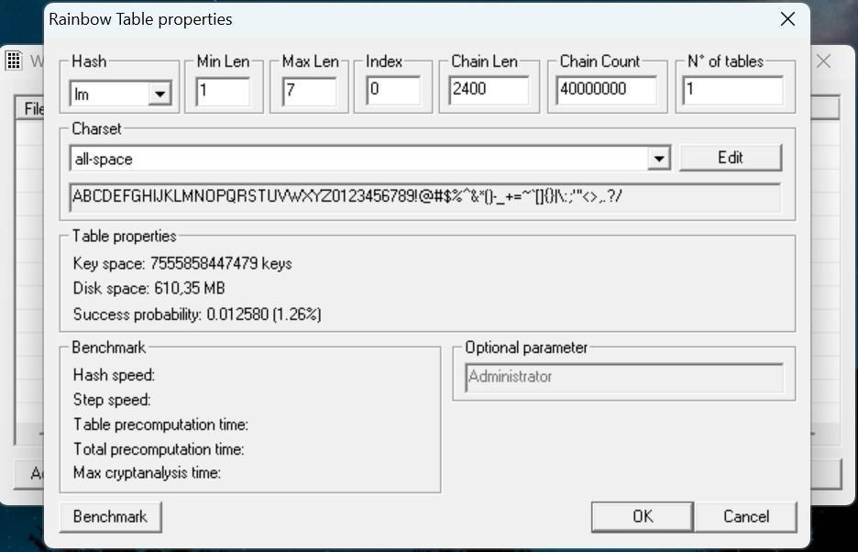

In the “**Rainbow Table Properties**” window we have the option to modify settings in order to generate rainbow tables according to our needs. The following properties can be modified:

• **Hash**: The type of encryption we want the rainbow table to be generated. For example MD5, MD4, SHA1, etc.

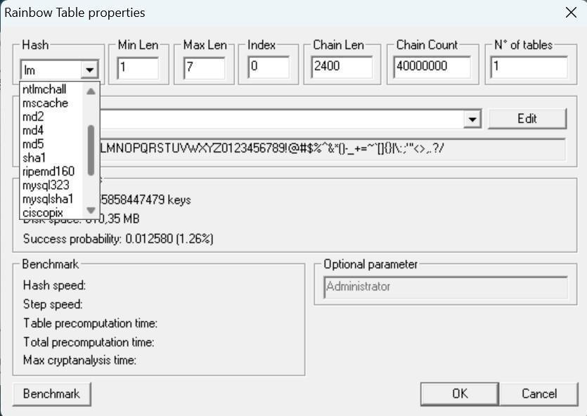

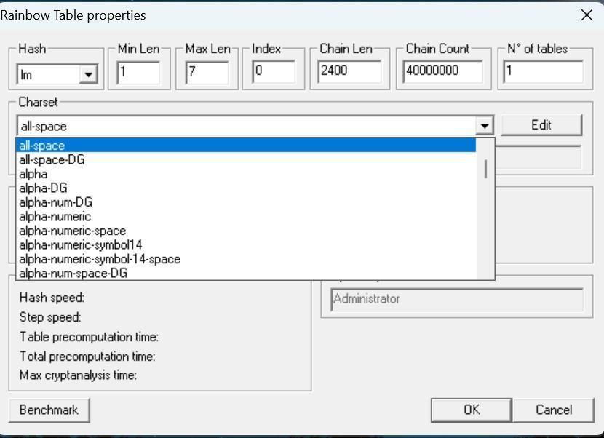

After assigning the values to the properties according to our needs click on “Benchmarks”. This will show the estimated time, Hash speed, Step speed, Table Pre-computing time, etc. that will be required to generate the Rainbow Table according to assigned properties.

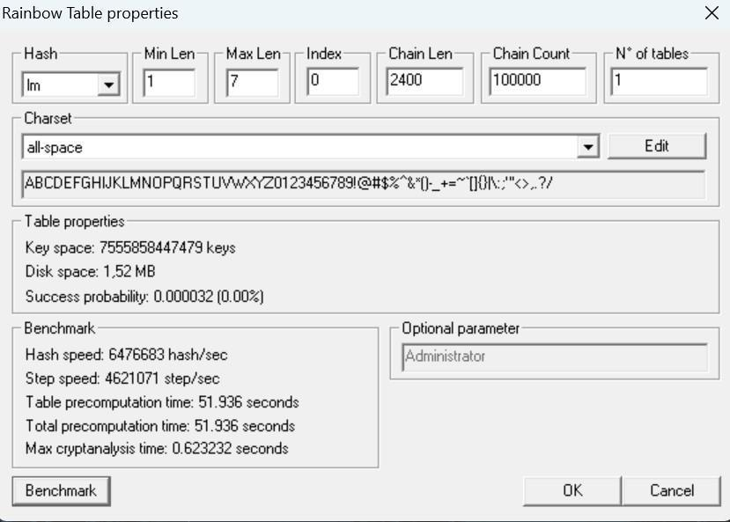

After “Benchmark” click on “Ok”. This will add the Rainbow Table to the queue in the main window of WinRTGen

. 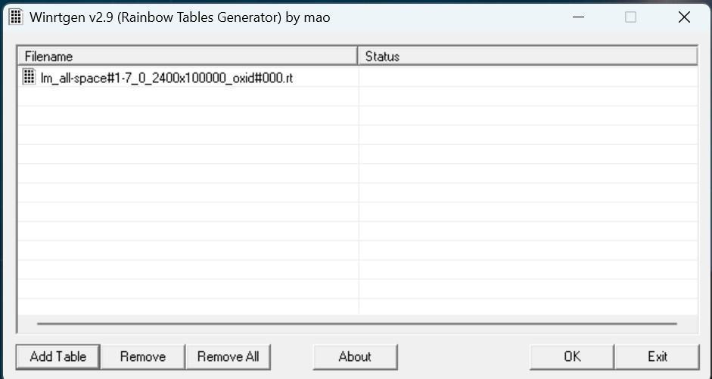

After this click on “Rainbow Table” You want to start processing and click “OK” .

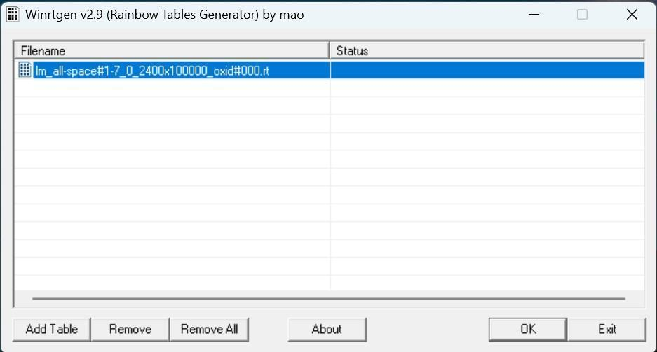

After clicking on ‘OK’ the WinRTGen” will start generating a rainbow table.

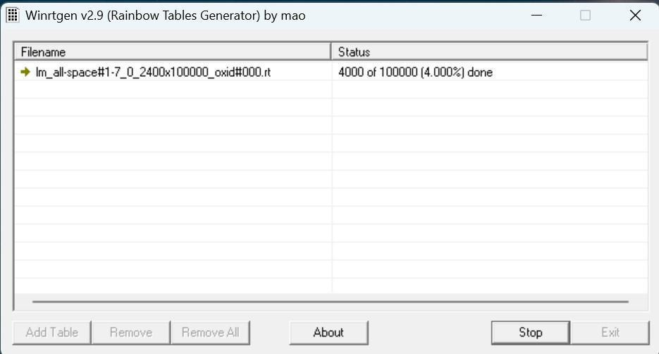

After completion, the window will appear as follows.

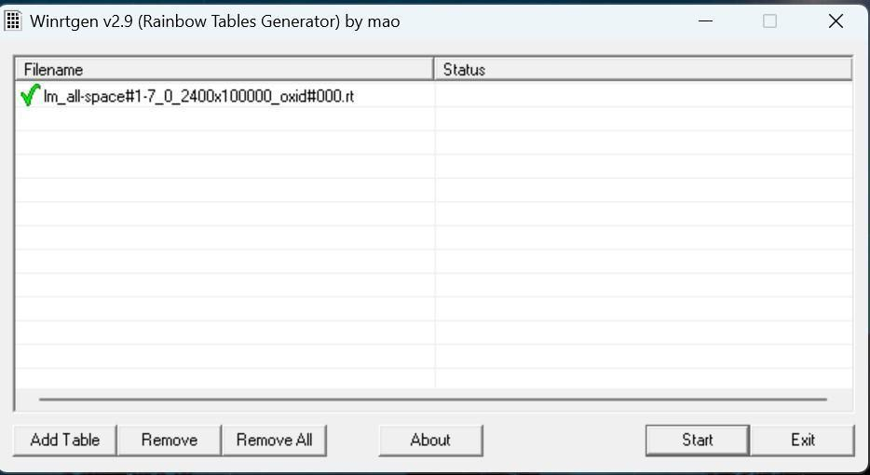

This table will be saved to your WinRTGen Directory.

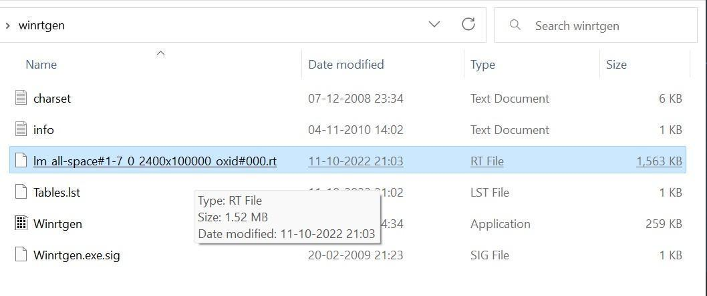

**ii. PWDump**

As a result, it will spill all the hashes kept in the SAM file. The next step is to use the commands below to save the registry values for the SAM file and system file in a system file:

*reg save hklm\sam c:\sam reg save hklm\system c:\system*

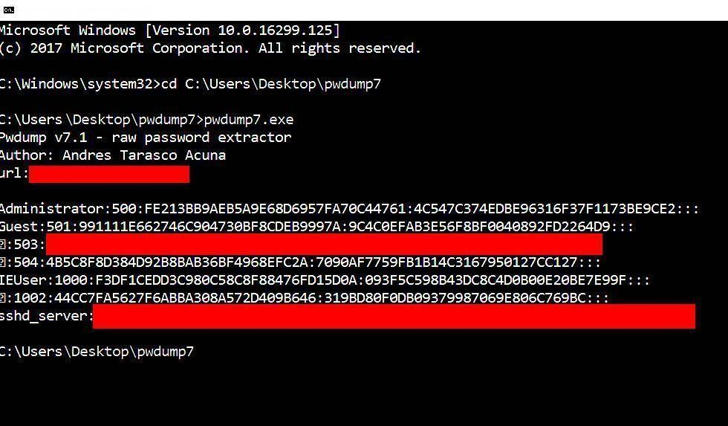

**# cd c:\Users\Download\Pwdump**

**# pwdump7.exe >> pass.txt (Save the output)**

## iii. Ophcrack

**Step 1**: Since we are assuming that your Windows PC is locked and you do not know the password, the first step needs to be carried out on a different PC with internet access and administrator privileges.

**Step 2** : Download the correct version of Ophcrack Live CD from the official website to the second PC.

**Step 3** : [Burn the ISO file to a USB](https://www.passmoz.com/burn-iso-image-to-usb-in-3-ways.html) or CD. To do this, you will need an ISO burning application. Now proceed to the next step of the password reset process.

**Step 4** : Remove the bootable media from the second PC and insert it into your locked Windows machine. Let the computer boot up from this media instead of the native Windows installation. This is made possible by the fact that Ophcrack itself contains a small operating system that can run independently of your Windows OS. In a few moments, you will see the Ophcrack interface on your computer.

**Step 5** : You will now see a menu with 4 options. Leave it on the default option, which is automatic. After a few seconds, you will see the Ophcrack Live CD loading and then the disk partition information being displayed as Ophcrack identifies the one with the SAM file. **Step 6** : Once the process has been completed, you will see a window with several user accounts and their passwords displayed in column format. Against the previously locked username, look for an entry in the NT Pwd column.

**Step 7**: This will be your recovered password, so note it down. You can now remove the Live CD from the drive and restart your computer. You will be able to login to your user account using the password that was recovered by Ophcrack.

[**https://ophcrack.sourceforge.io/tables.php**](https://ophcrack.sourceforge.io/tables.php) **(download rainbow table)**

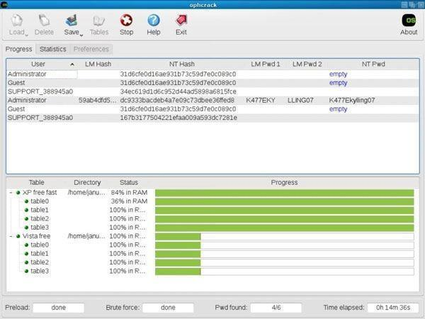

## iv. NTFS Stream Manipulation

The following is the syntax of ADSs filename extension :alternative Nmae. Open the terminal and type the following command to create a file named file_1.txt. echo

"this is file no 1" > file_1.txt

Now, type the following command to write to the stream named secret.txt. echo "this is a hidden file inside the file_1.txt" > file_1.txt:secret.txt

**# notepad Test.txt**

**# notepad Test.txt:secret.txt**

**# echo “Hii secret data” > Test.txt:secret.txt**

**# more < Test.txt:secret.txt > open.txt**

**# more open.txt**

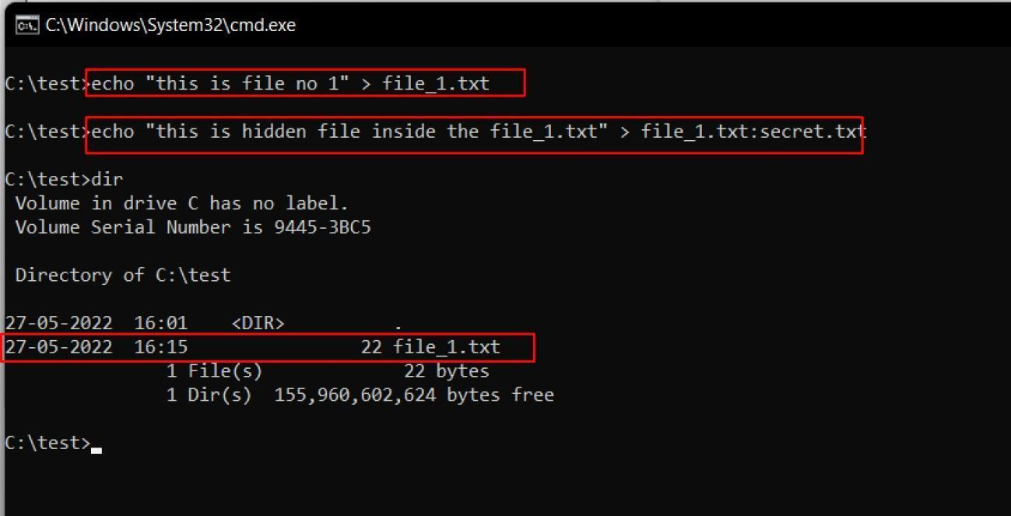

We’ve just created a stream named secret.txt that is associated with file_1.txt and when you look at the file_1.txt you will only find the data present in file_1.txt. And also stream will not be shown in the directory as well.

The following command can be used to view or modify the stream hidden in file_1.txt notepad file_1.txt:secret.txt

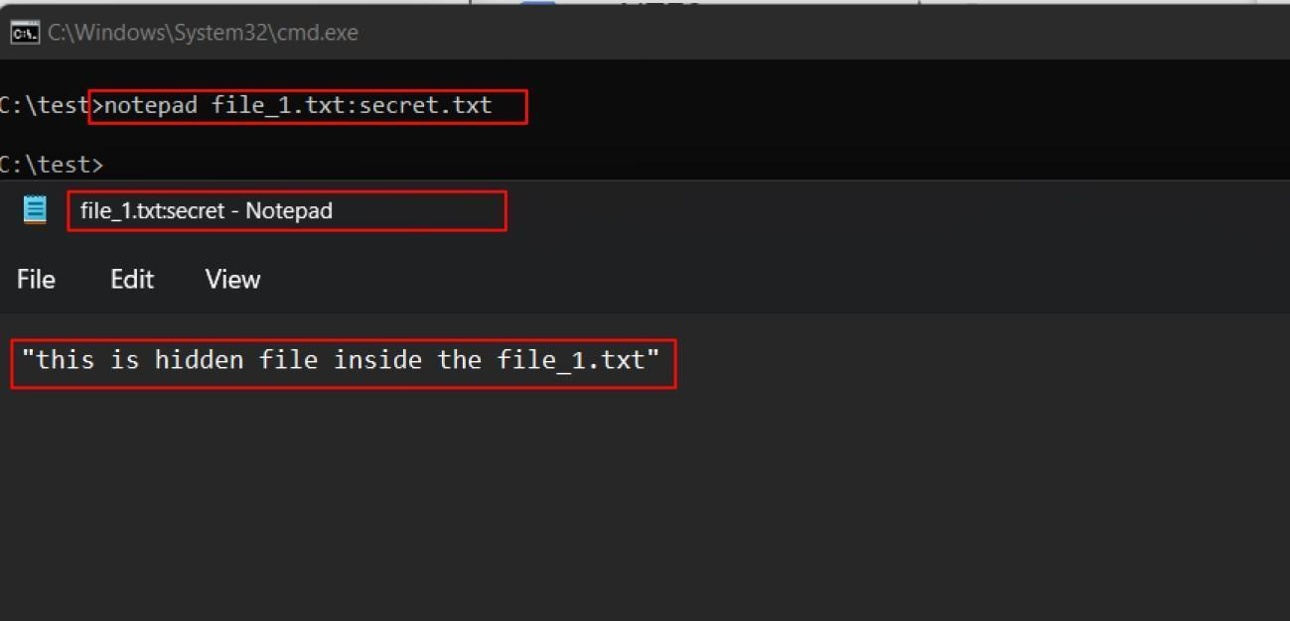

**Note:** Notepad is a stream-compliant application. Never use alternative streams to store sensitive information.

Hiding Trojan.exe in note.txt file stream:

The following command has used the copy the trojan.exe into a note.txt(stream)

C:\test>type Trojan.exe > note.txt:Trojan.exe

Here type command is used to hide trojan in the ADS inside an existing file.

After hiding trojan.exe behind note.txt, we need to create a link to launch the trojan.exe file from the stream. The following command is used to create a shortcut in the stream.

C:\test>mklink game.exe note.txt:Trojan.exe

Type game.exe to run the trojan that is hidden behind the note.txt. Here, game.exe is the shortcut created to launch trojan.exe.

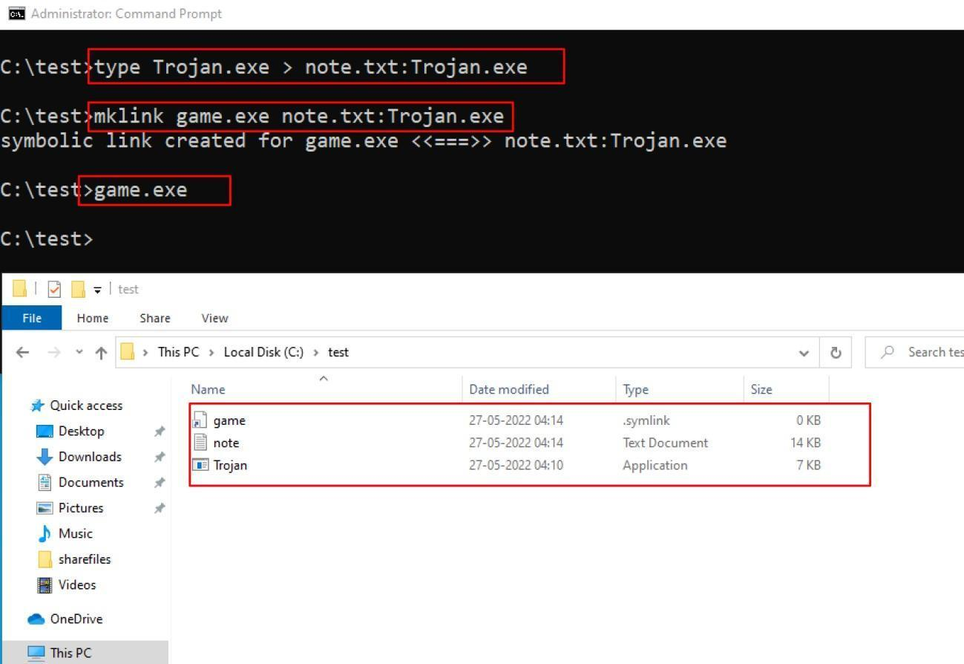

## v. ADS Spy

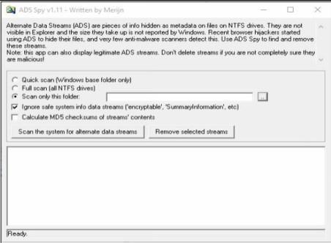

As we store the file in the Document folder, Selecting Document folder to scan particular folder only.

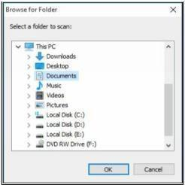

Select an Option, if you want to scan for ADS, click “**Scan the system for ADS**”/ or click **removes** button to remove the file ‘

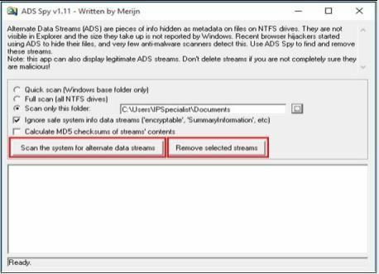

As shown in the figure below, ADS Spy has detected the **Testfile.txt:hidden.txt** file from the directory.

## 

## vi. Snow

Create a text file with some data in the same directory where Snow Tool is installed.

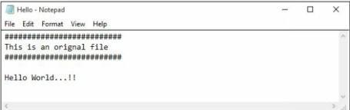

Go to Command Prompt

Change the directory to run Snow tool

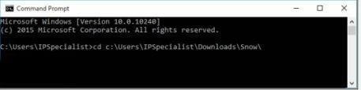

Type the command

**Snow –C –m “text to be hide” –p “password” <Sourcefile> <Destinationfile>**

The source file is a Hello.txt file as shown above. Destination file will be the exact copy of source file containing hidden information.

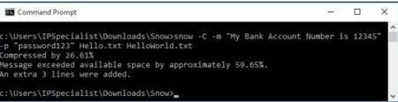

Go to the directory; you will a new file **HelloWorld.txt**. Open the File

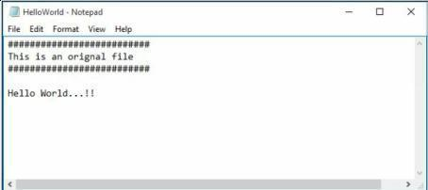

New File has the same text as an original file without any hidden information. This file can be sent to the target.

### Recovering Hidden Information

On destination, Receiver can reveal information by using the command

**Snow –C –p “password123” HelloWorld.txt**

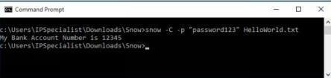

As shown in the above figure, File decrypted, showing hidden information encrypted in the previous section.

## vii. Quickstego

**Image Steganography using QuickStego**

1. Open QuickStego Application

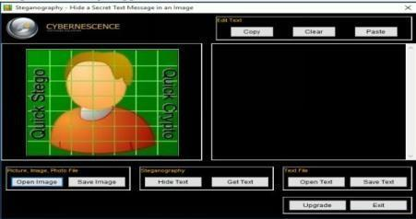

1. Upload an Image. This Image is term as **Cover**, as it will hide the text.

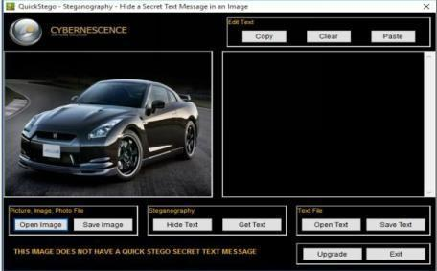

1. Enter the Text or Upload Text File

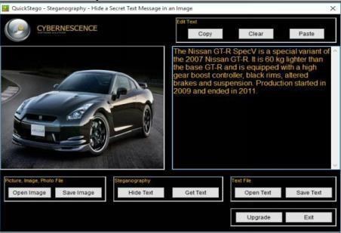

1. Click Hide Text Button

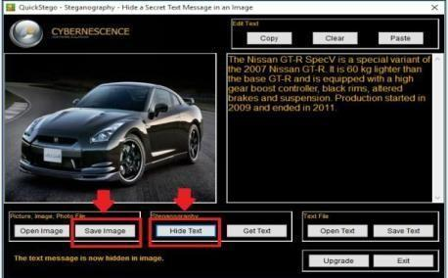

1. Save Image

This Saved Image containing Hidden information is termed as Stego Object.

**Recovering Data from Image Steganography using QuickStego**

1. Open QuickStego
2. Click Get Text

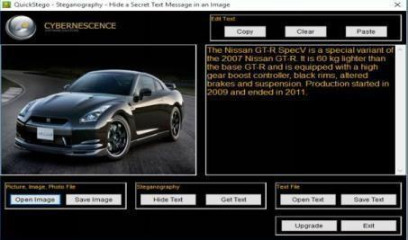

1. Open and Compare Both Images

Left Image is without Hidden Text; Right Image is with hidden text



## viii. Clearing Audit Policies

### Enabling and Clearing Audit Policies

To check command’s available option Enter C:\Windows\system32> **auditpol /?**

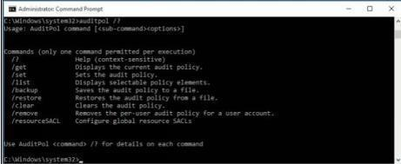

Enter the following command to enable auditing for System and Account logon: -

C:\Windows\system32>**auditpol /set /category:"System","Account logon" /success:enable /failure:enable**

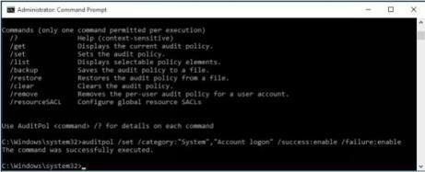

To check Auditing is enabled, enter the command

C:\Windows\system32>**auditpol /get /category:"Account logon","System"**

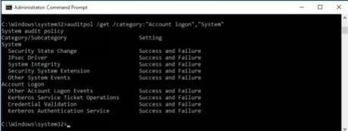

To clear Audit Policies, Enter the following command

C:\Windows\system32>**auditpol /clear**

Are you sure (Press N to cancel or any other key to continue)?**Y**

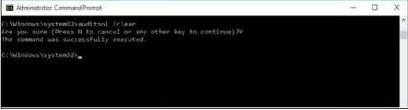

To check Auditing, enter the command

C:\Windows\system32>**auditpol /get /category:"Account logon","System"**

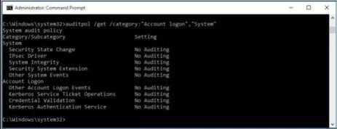

## ix. Clearing Logs

1. Go to Kali Linux Machine
2. Go to /**var/Logs** folder:

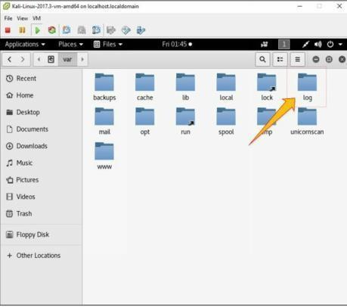

1. Select any log file:

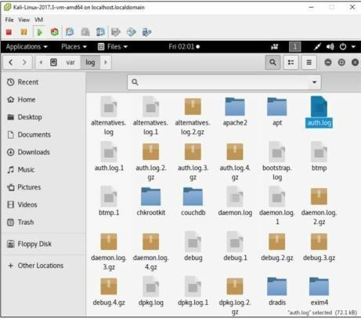

1. Open any log file; you can delete

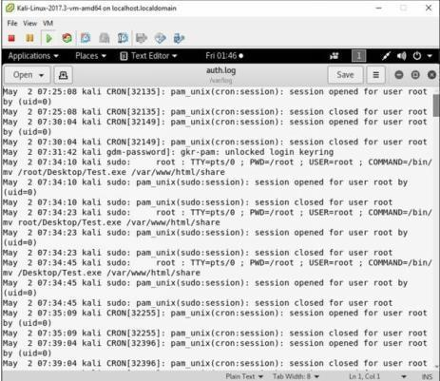

# Practical No. 5

**a. Use Wireshark to sniff the network.**

* Start Wireshark. Under the “Capture” header, select the “Interface List” option; or click on the “Interfaces” button on the toolbar:

This will bring up a list of network interfaces that Wireshark is able to capture packets from:

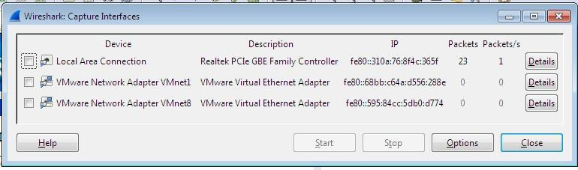

List of available capture interfaces

Select the network adapter (wired or wireless) that you are currently using to connect to the Internet, and hit the “Start” button. This will take you to the main window:

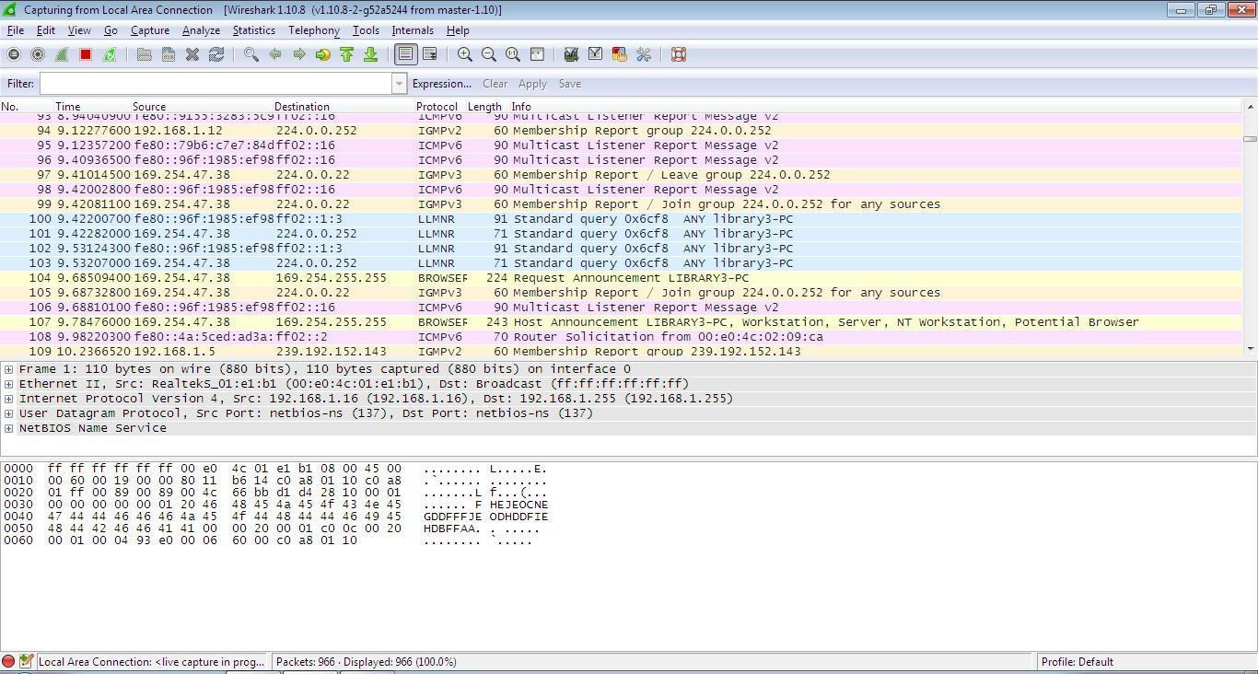

Wireshark is now capturing live network activity on your network interface. Notice that the list of packets is color-coded to highlight different types of network traffic.

* Open your web browser and navigate to a few random web pages - observe that the network packets corresponding to your web browsing activity are captured and show up in Wireshark as well.
* By default, the list of captured packets will keep scrolling automatically during a live capture. You can toggle this on/off using the AutoScroll toggle button in the toolbar.

* After letting the capture run for a couple of minutes, press the stop capture button. Do not close this capture session.

**Filtering the Packet List**

Capturing network traffic for a couple minutes could include traffic on many different protocols such as ARP, TCP, UDP, DNS, HTTP, etc.

We may not be interested in all of these, depending on what we are trying to achieve. Fortunately, Wireshark allows us to filter the list based on different criteria using the “Filter” toolbar:



**Filter toolbar**

Let us take a look at the HTTP traffic that occurs when we browse the web.

In the filter toolbar, type “http” and then click on “Apply”. The window will now list only captured packets related to HTTP traffic:

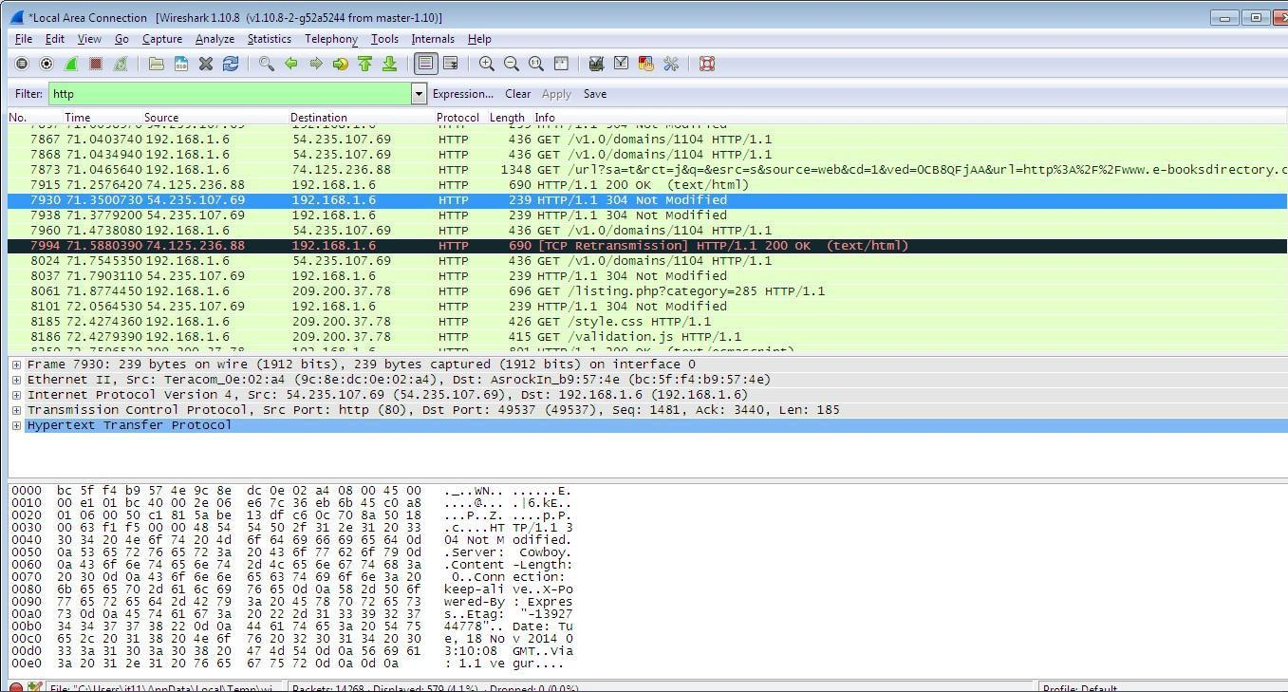

**Examining HTTP Traffic**

The HTTP traffic that occurs during web browsing.

* Stop and close any capture that you may have open, and start a new capture.
* Set the filter to show only HTTP traffic.

Start with the HTTP request sent from your web browser.

* In your web browser, navigate to some webpage like [http://wwwscf.usc.edu/~csci571/Special/HTTP/proxy.html.](http://www-scf.usc.edu/~csci571/Special/HTTP/proxy.html)
* In the top frame of the Wireshark main window, look for the packet that corresponds to your request. This contains the URL in the “Info” section. Select this packet.
* In the middle frame of the Wireshark window, expand the “Hypertext Transfer Protocol” section. Notice the details given for the:
  + GET request o Host o User-Agent o Accepts o cookie o etc

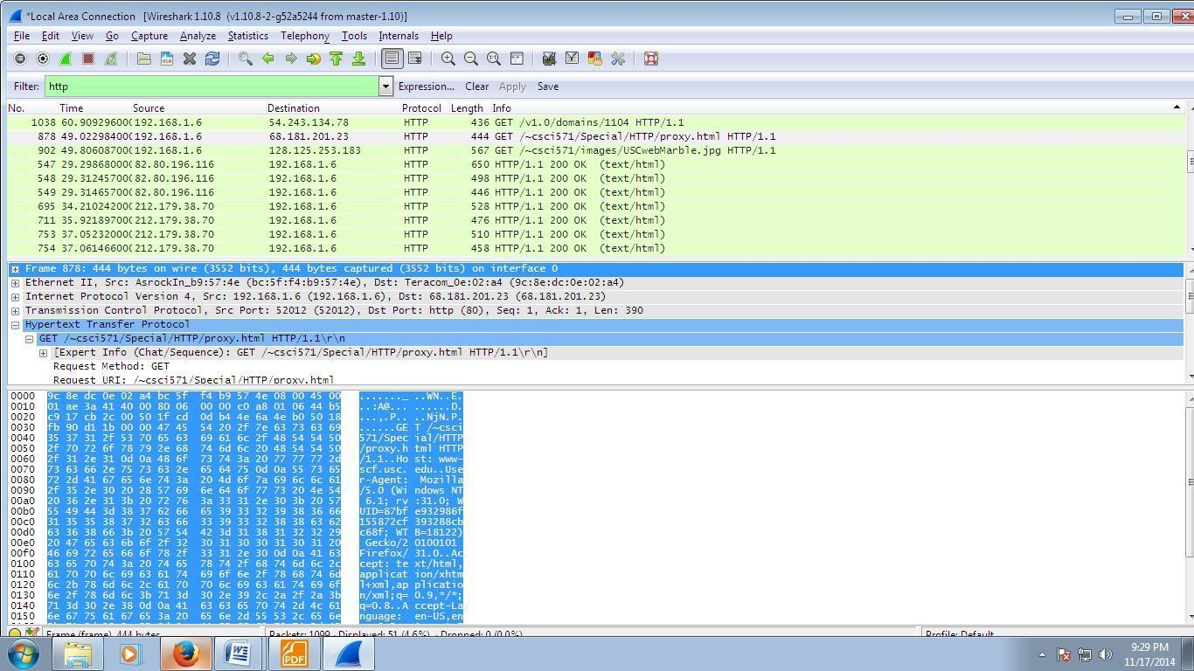

Take a look at the HTTP response to the above request.

In the top frame of the Wireshark main window, find and select the “HTTP/1.1 200 OK” packet immediately below the request for proxy.html. This is the response containing the requested web page.

Again, expand the “Hypertext Transfer Protocol” section. Notice the details given for o Cache-Control o Content-Type o Server

* + Etc

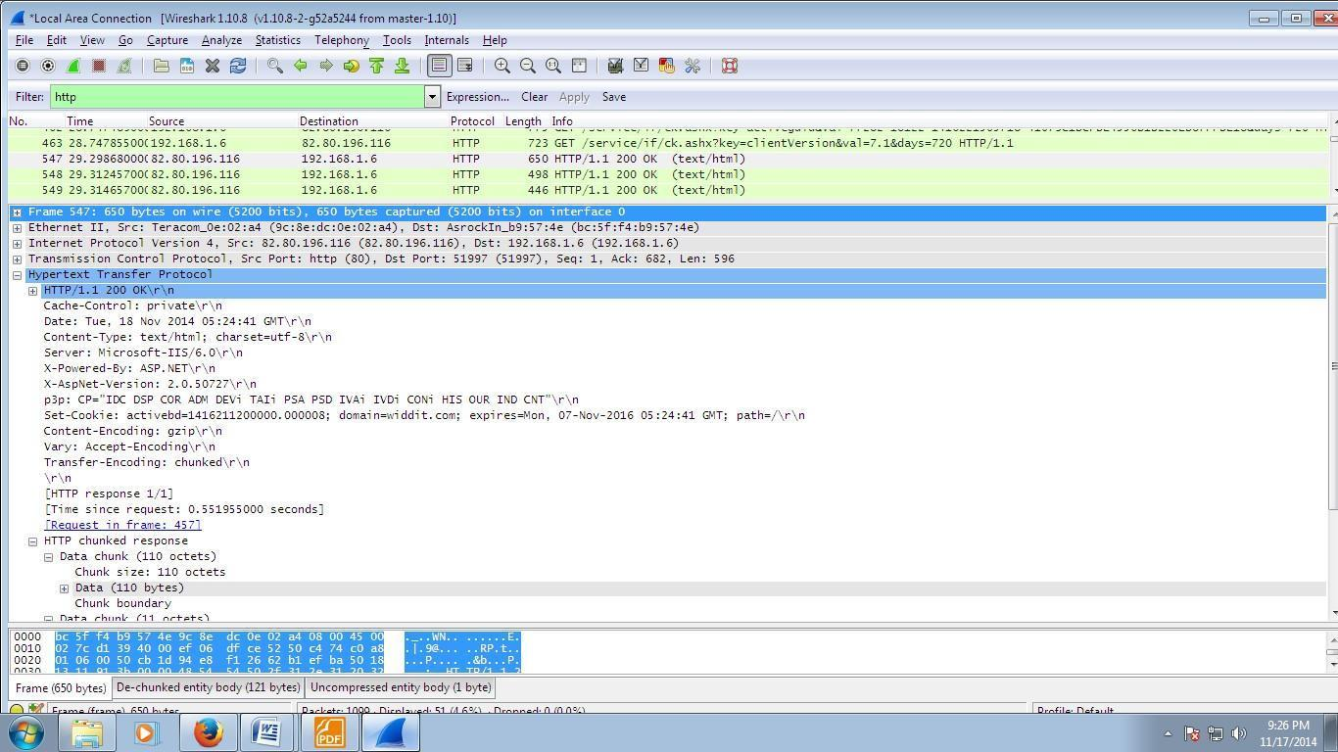

Details of incoming HTTP response corresponding to proxy.html

**b. Use SMAC for MAC Spoofing.**

Click on that folder and you will see SMAC 2.0. Click on that launcher and the SMAC main window **Figure** will open.

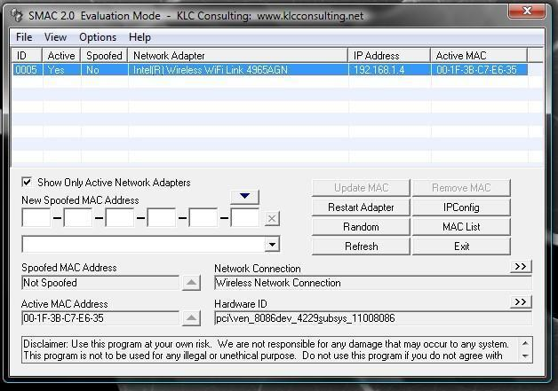

Take a look at **Figure** to see how much the listing grows on my laptop that includes wireless, wired, and dial-up connections.

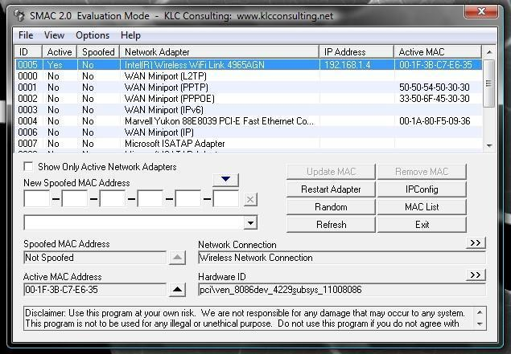

When you click on a different listing, the information about that hardware will be displayed below.

Let’s change the MAC address of the Wired Marvell Yukon PCI-E Faster Ethernet Controller. To do this, select that entry from the list and click the Random button. As you can see in **Figure** , the new, random MAC address is displayed in the New Spoofed MAC Address section.

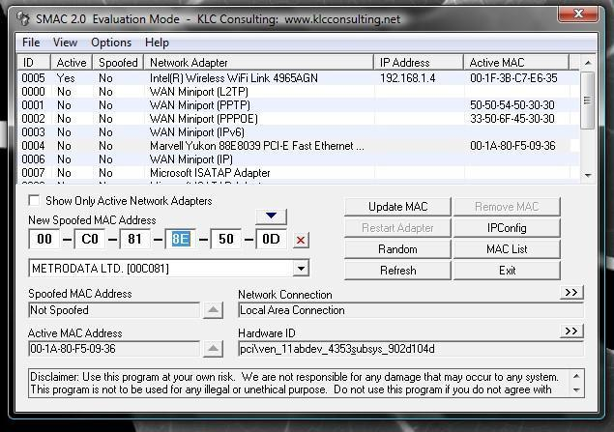

The address listed will correspond to a manufacturer list that you can choose from.

If you know you want to spoof your MAC address to that of a specific manufacturer you can select a different manufacturer from the drop-down list. When you make this selection, the address listed will change. You can keep hitting Random until you get an address you like (or you can just take the first random address you get).

Once you have your address, select the Options menu and make sure Automatically Restart Adapter is checked. Once that is checked, hit the Update MAC Address button and the new MAC address will be applied.

# Practical No. 6

**a. Use Social Engineering Toolkit on Kali Linux to perform Social Engineering using Kali Linux.**

We are using Kali Linux Social Engineering Toolkit to clone a website and send clone link to victim. Once Victim attempt to login to the website using the link, his credentials will be extracted from Linux terminal.

**Procedure:**

1. Click Social Engineering Tools
2. Click Social Engineering Toolkit

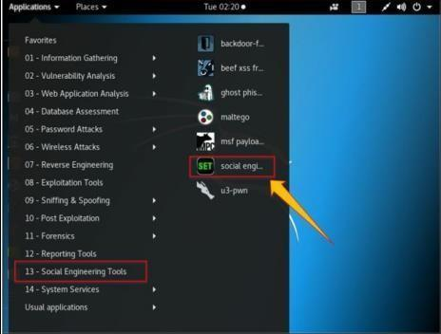

1. Enter “Y” to proceed.

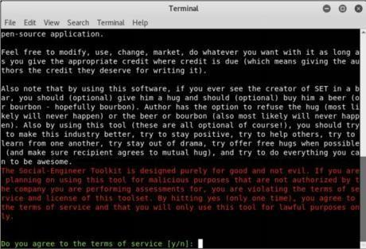

1. Type “1” for Social Engineering Attacks

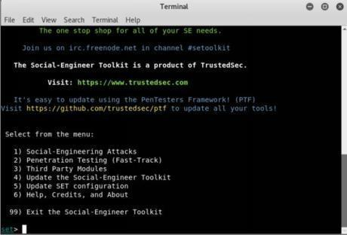

1. Type “2” for website attack vector

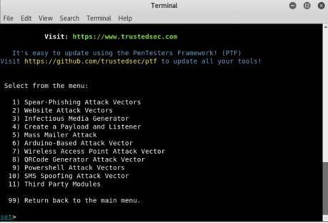

1. Type “3” for Credentials harvester attack method

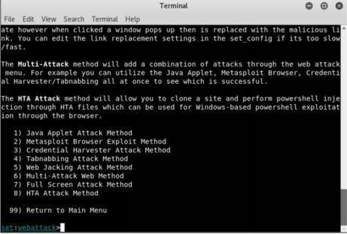

1. Type “2” for Site Cloner

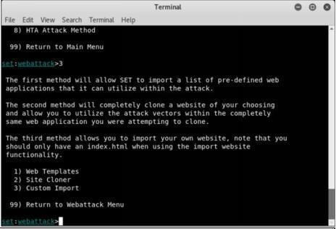

1. Type IP address of Kali Linux machine (10.10.50.200 in our case).

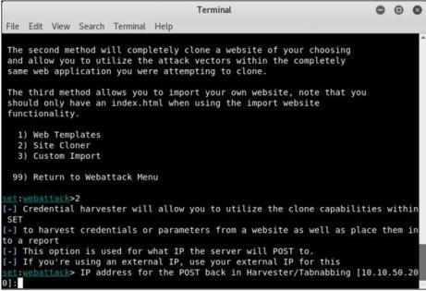

1. Type target URL

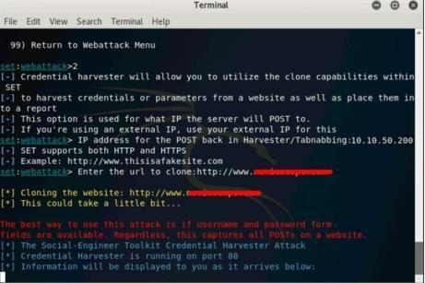

1. Now, http://10.10.50.200 will be used. We can use this address directly, but it is not an effective way in real scenarios. This address is hidden in a fake URL and forwarded to the victim. Due to cloning, the user could not identify the fake website unless he observes the URL. If he accidentally clicks and attempts to log in, credentials will be fetched to Linux terminal. In the figure below, we are using http://10.10.50.200 to proceed.

1. Login using username and Password

Username: admin

Password: Admin@123

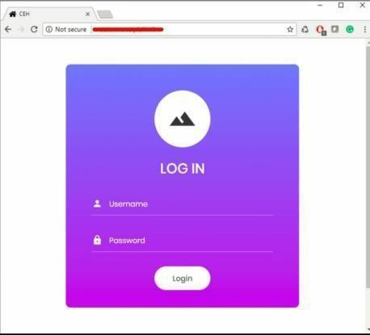

1. Go back to Linux terminal and observe.

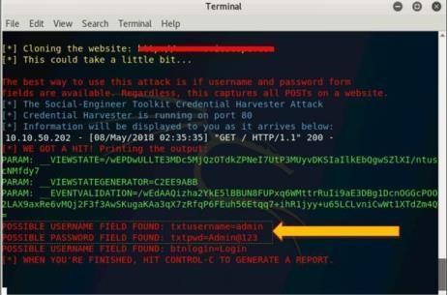

Username admin and password is extracted. If the user types it correctly, exact spelling can be used. However, you will get the closest guess of user ID and password. The victim will observe a page redirect, and he will be redirected to a legitimate site where he can re-attempt to log in and browse the site.

**b. Perform the DDOS attack using the following tools:**

## i. HOIC

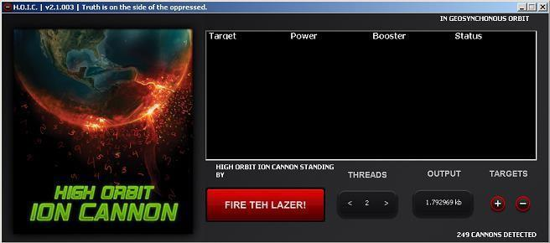

## ii. LOIC

See the basic screen of the tool in the snapshot above in Figure.

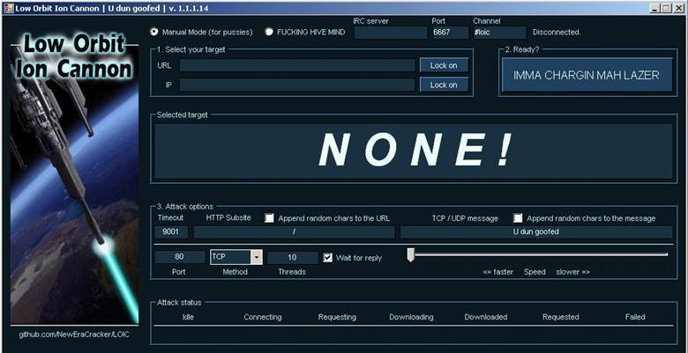

* **Step 1:** Run the tool.
* **Step 2:** Enter the URL of the website in The URL field and click on Lock On. Then, select attack method (TCP, UDP or HTTP). I will recommend TCP to start. These 2 options are necessary to start the attack.

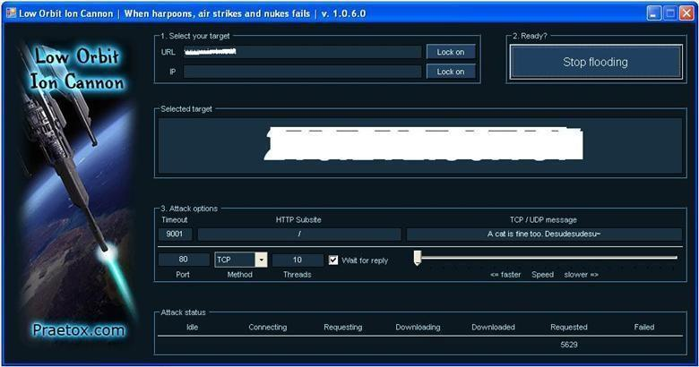

Figure3: LOIC in action (I painted the URL and IP white to hide the identity of the victim in snap) • **Step 3:** Change other parameters per your choice or leave it to the default. Now click on the Big Button labeled as “IMMA CHARGIN MAH LAZER.” You have just mounted an attack on the target.

After starting the attack you will see some numbers in the Attack status fields. When the requested number stops increasing, restart the LOIC or change the IP. You can also give the UDP attack a try. Users can also set the speed of the attack by the slider. It is set to faster as default but you can slow down it with the slider. I don’t think anyone is going to slow down the attack.

## iii. Metasploit

First, select your target’s IP address. I am taking **testphp.vulnweb.com** as a victim. So you know how to get an IP address from a domain name. Simple doping and that will give to domain IP address.

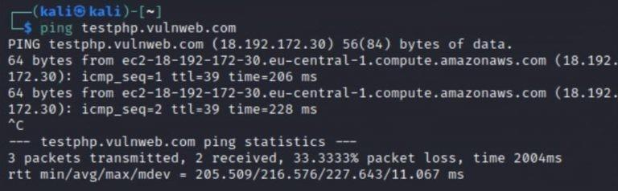

So now I know the victim’s IP Address **18.192.182.30.**

Launching Metasploit by typing **msfconsole** in your kali terminal

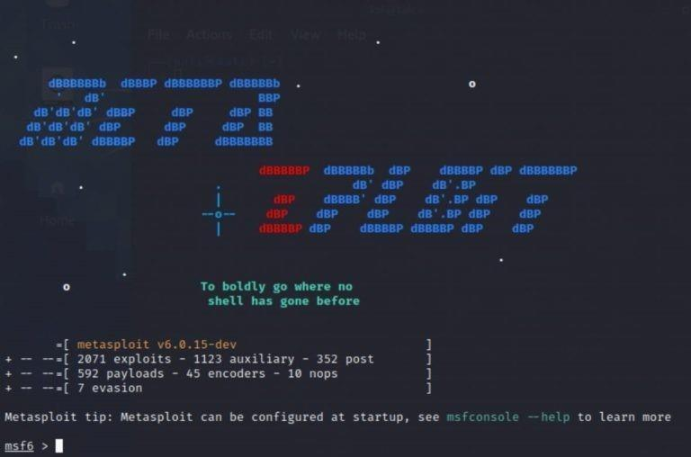

Then use the select the auxiliary “auxiliary/dos/TCP/synflood” by typing the following command.

**Msf6 > use auxiliary/dos/tcp/synflood**

**Msf6> show options**

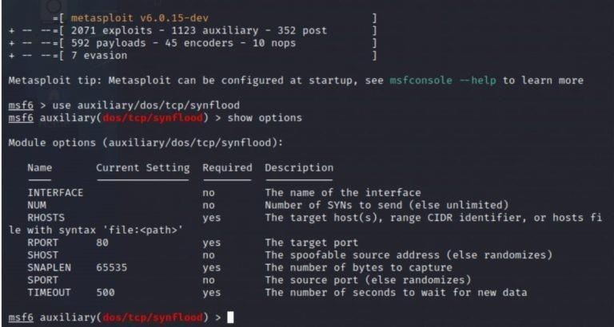

Now you can see you have all the available options that you can set.

To set an option just you have to type **set** and the **option name** and option.

You have to set two main option

RHOST= target IP Address

RPORT=target PORT Address

**Set RPORT 18.192.182.30**

**Set RPORT 80**

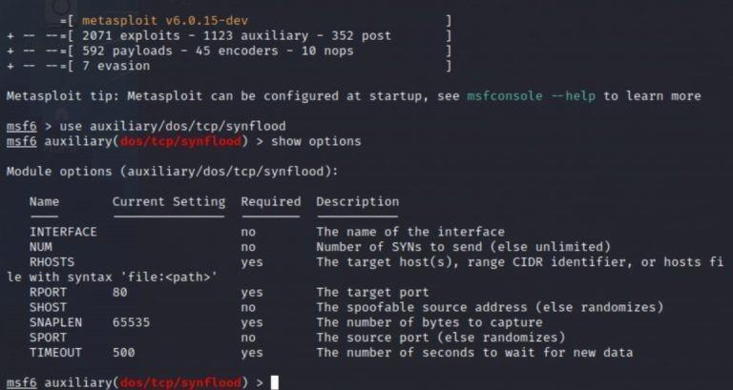

To launch the attack just type. **exploit**

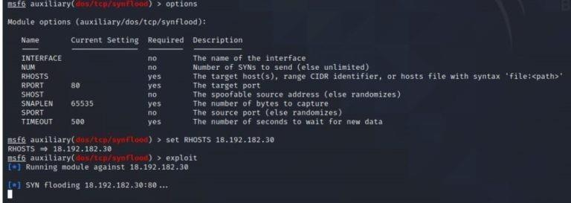

to see the packets you can open Wireshark.

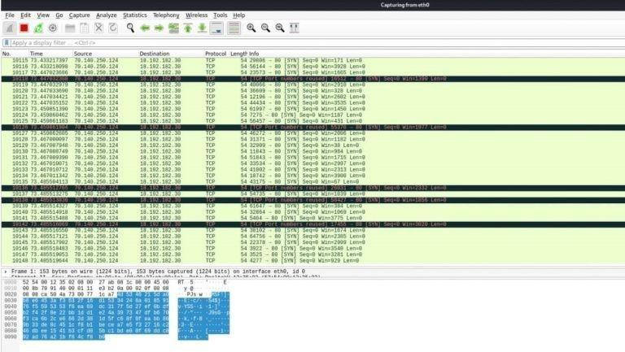

So that’s how you can perform a DOS attack.

# Practical No. 7

**a. Use the following tools to protect attacks on the web servers:**

## i. ID Server

Download and install ID Server tool.

1. Enter URL or IP address of the target server

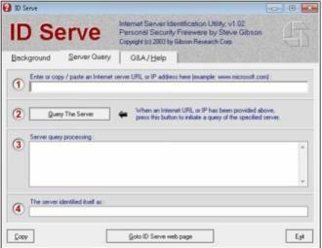

1. Enter the **Query The Server**/button.

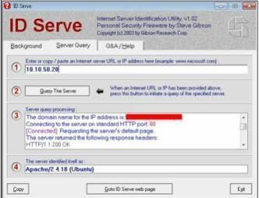

1. Copy the Extracted information.

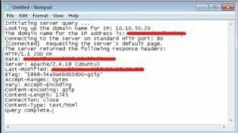

Information such as Domain name, open ports, Server type and other information are extracted.

# Practical No. 8

## Use the following tools for cryptography

## i. HashCalc

## 

**Calculating MD5 value using HashCalc**

1. Open HashCalc tool.

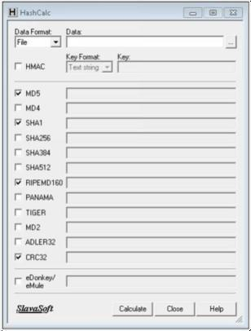

1. Create a new file with some content in it as shown below.

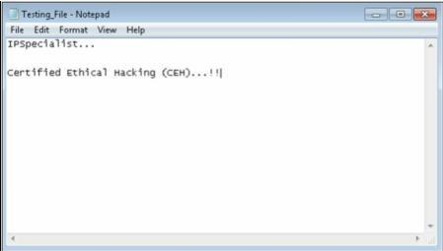

1. Select Data Format as “File” and upload your file

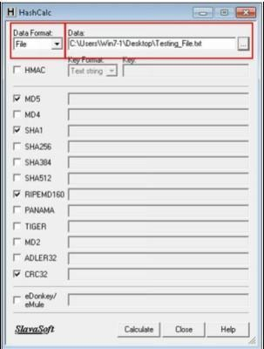

1. Select Hashing Algorithm and Click Calculate

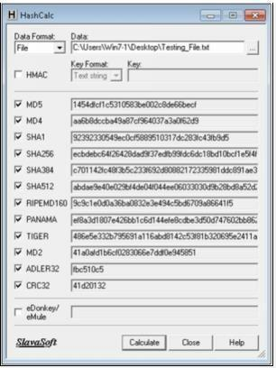

1. Now Select the Data Format to “**Text String**” and Type “**IPSpecialist…**” into Data filed and calculated MD5.

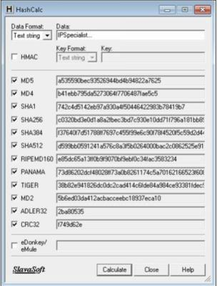

MD5 Calculated for the text string “**IPSpecialist…**” is

“**a535590bec93526944bd4b94822a7625**”

1. Now, let's see how MD5 value is changed from minor change.

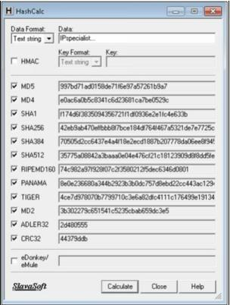

Just lowering the case of single alphabet changes entire hashing value. MD5 Calculated for the text string “**IPspecialist…**” is “**997bd71ad0158de71f6e97a57261b9a7”**

## ii. Advanced Encryption Package

1. Download and Install Advance Encryption Package Latest Version. In this Lab, we are using Advanced Encryption Package 2014 and 2017 to ensure compatibilities on Windows 7 and Windows 10.

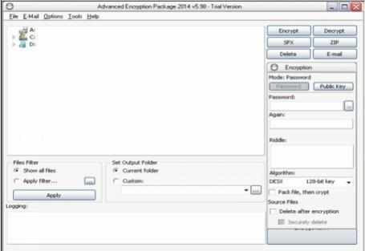

1. Select the File you want to Encrypt.
2. Set password
3. Select Algorithm

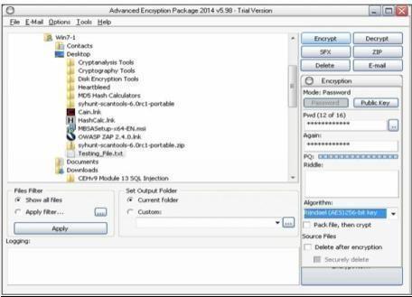

1. Click Encrypt

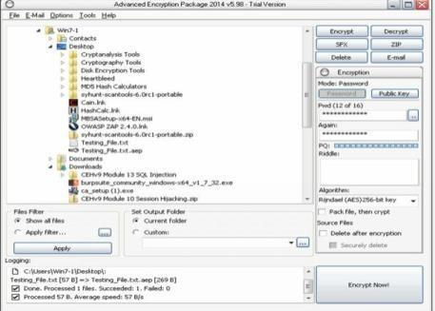

1. Compare both Files

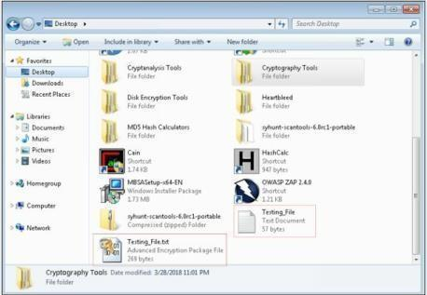

1. Now, After forwarding it to another PC, in our case, in Windows 10 PC, decrypting it using Advanced Encryption package 2017.
2. Enter password

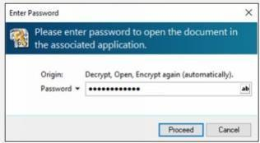

1. File Successfully decrypted.

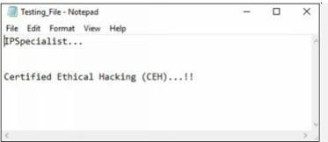

## iii. CrypTool

## 

Cryptool is a free e-learning tool to illustrate the concepts of cryptography. Try Various Encryption/Decryption algorithms.

